QIP Quality Metric

User Guide

Document No: | revised
Revision No: | 2.0
Author: | Jim Kobylecky et al
Company: | VSIA



Copyright 2005
VSI Alliance, Inc.
15495 Los Gatos Boulevard, Suite #3
Los Gatos, California 95032, USA
Phone: (408) 356-8800, Fax: (408) 356-9018
Web: http://www.vsi.org, email: info@vsi.org

This draft Manual is provided for review purposes only. VSI Alliance has no obligation to issue the draft Manual in its current form or in any other form. The draft Manual may describe technology that is patented or subject to other intellectual property claims of third parties.

Release of the draft Manual for review purposes does not mean that the owner of the patents or other intellectual property rights has authorized the use thereof in the Specification or will do so in any version of the Manual, which VSI Alliance may hereafter release.

VSI Alliance is a trademark of the VSI Alliance, Inc. All other trademarks are the property of their respective owners
NOTICE
THE DOCUMENT IS PROVIDED BY VSIA ON AN “AS-IS” BASIS, AND THE VSIA HAS NO OBLIGATION TO PROVIDE ANY LEGAL OR TECHNICAL ASSISTANCE IN RESPECT THERETO, TO IMPROVE, ENHANCE, MAINTAIN OR MODIFY THE DOCUMENT, OR TO CORRECT ANY ERRORS THEREIN. VSIA SHALL HAVE NO OBLIGATION FOR LOSS OF DATA OR FOR ANY OTHER DAMAGES, INCLUDING SPECIAL OR CONSEQUENTIAL DAMAGES, IN CONNECTION WITH THE USE OF THE DOCUMENT. VSIA MAKES NO REPRESENTATIONS OR WARRANTIES, EXPRESS OR IMPLIED, INCLUDING WITHOUT LIMITATIONS, ANY WARRANTY AS TO INFRINGEMENT, OR THE IMPLIED WARRANTIES OF MERCHANTABILITY AND FITNESS FOR A PARTICULAR PURPOSE. USERS SHOULD BE AWARE THAT IMPLEMENTATION OF THE DOCUMENT MAY REQUIRE USE OF SUBJECT MATTER COVERED BY PATENT OR OTHER INTELLECTUAL PROPERTY RIGHTS OF THIRD PARTIES. NO LICENSE, IMMUNITY, OR OTHER RIGHT IS GRANTED BY THIS LICENSE IN ANY SUCH THIRD-PARTY RIGHTS. NEITHER VSIA NOR ITS MEMBERS TAKE ANY POSITION WITH RESPECT TO THE EXISTENCE OR VALIDITY OF ANY SUCH RIGHTS.

Change History

Version | Date | Author | Remarks
0A | 30-Jun-2003 | Phil Rose | Initial Revision
1.10 | 12 Apr 2004 | W. Billowitch | Updated in line with VSIA QIP v1.10
1.16 | 17 Dec 2004 | K. Werner | Updated in line with VSIA QIP V1.16
2A | May 27 2005 | J. Kobylecky | Redesigned for VSIA QIP V2.0 Beta
2.0 | 28 Dec 2005 | K. Werner | Final updates for 2.0 release
Table of Contents
1. Overview 1
1.1. What is an "IP"? 1
1.2. Is IP reuse really so important? 1
1.3. What is QIP? 2
1.3.1. We provide Virtual Advisors 2
1.3.2. You Make the Real Decisions 2
1.4. Who is the QIP for? 2
1.5. How do I use it? 3
1.6. How do I start using the QIP? 4
2. Jump-Start 5
2.1. Jump-Start for IP Vendors 5
2.1.1. Step One: Get started. 5
2.1.2. Step Two: Fill in the basic information. 5
2.1.3. Step Three: Select the Vendor Assessment worksheet. 5
2.1.4. Step Four: Answer the questions. 5
2.1.5. Step Five: Fill out another worksheet. 5
2.1.6. Step Six: Check your score 5
2.2. Jump-Start for IP User 6
2.2.1. Step One: Open a completed QIP spreadsheet. 6
2.2.2. Step Two: Examine at the scores. 6
2.2.3. Step Three: Examine the component worksheets 6
2.2.4. Step Four: Open a completed QIP for a competing IP. 6
3. Walkthroughs 7
3.1. Walkthrough for IP Vendors 7
3.1.1. Start with a blank copy of the QIP metric. 7
3.1.2. Set up a Vendor Template 7
3.1.3. Fill out the IP Development Worksheet 8
3.1.4. Fill out the IP Integration Worksheet 10
3.2. Walkthrough for IP Users 10
3.2.1. Open a completed QIP metric. 10
3.2.2. Examine the Summary Worksheet 11
3.2.3. Customizing the QIP for your project 13
4. Operator's Reference 15
4.1. How does the QIP metric work? 15
4.1.1. The QIP follows standard MS Excel conventions. 15
4.2. Understanding scores 15
4.2.1. Underlying Scores 16
4.2.2. Traffic Lights and Grades 16
4.3. Interactive Questions 18
4.4. How scores add up 18
4.4.1. Total QIP Metric 18
4.4.2. An alternate explanation of the Traffic Light Display 18
4.5. Saving the results 18
5. Troubleshooting and FAQ 18
5.1.1. Excel Compatibility or Why won't it run on my computer? 18
5.1.2. Macros or It still won't run on my computer? 18
5.1.3. Type of IP or Why can't I evaluate more than one type of IP? 18
5.1.4. Type of assessment or Why can't I see the Integration worksheet? or Why can't I see the Verification worksheet? 18
5.1.5. I have more questions than you have answers or How can I contact tech support? 18
Appendixes 18
Referenced Documents 18

Overview
The fastest way to grow technology is to build on the work of others. Designing a new SoC (System on Chip) is a good example. Using the right IP (Intellectual Property) to supply routine functions saves system integrators time and enables them to concentrate on their unique elements. Picking the wrong IP, however, can complicate their tasks, induce time delays, and cause more harm than good.
The best course of action? Always pick the "right" IP. But how do you do it? How can you confidently compare IP's from different vendors, rank your choices, and make intelligent decisions?
When evaluating competing IP, the quickest answer is to compare QIP (Quality IP) scores. Decide. Get back to work.

What is an "IP"?
Although "Intellectual Property" or "IP" is the most widely used industry term, you may be used to calling them something else. Some industry experts prefer the term "VC" (Virtual Component) to better describe how they are used.
Whichever name you prefer, these "black-box" cores or micro-devices are generally used to handle routine system functions. They are also designed to be easily integrated into new systems. That is why system integrators can use them as building blocks to quickly construct SoC and other solutions.

Is IP reuse really so important?
Yes. Reusing well-designed IP has become good design practice. It can lower risk and increase opportunity.
Consider that every design decision balances risk and opportunity. With so many competitive pressures on SoC design, it is hard to justify the time and resources necessary to create everything from scratch. Reuse improves the chances of first-time silicon success. It can reduce the number of re-spins and their associated mask costs. Reuse decreases the time it takes to design and deliver a product to market. Reuse lets designers focus on their core competencies, creating new ideas and products, and saves them from the distraction of having to reinvent the wheel – again.
A side note: Don't confuse IP reuse with recycling. Reuse takes advantage of the portability and savings of confidently integrating proven IP into a system. Recycling, however, usually means hooking together bits and pieces of old code and hoping for the best. While recycling may create a good conceptual starting point, one has to anticipate increased risk and plan for extra customization, development, and verification costs. When choosing IP that has been designed and proven for reuse, you expect to save time, not spend more of it.

What is QIP?
The Quality IP Metric (QIP) is an objective way to compare IP for reuse on an "apples" to "apples" basis. The QIP consists of interactive Microsoft Excel™ spreadsheets with sets of questions to be answered by the IP vendor. The QIP examines the practices used to design, integrate and support the IP. Among similar IPs, the higher the QIP score, the higher will be the probability of successful reuse.
The VSI Alliance's Quality Pillar developed the QIP to help IP users evaluate similar IPs and to help IP vendors clearly display their quality standards.

We provide Virtual Advisors
When the VSIA Quality Pillar developed the QIP metric, they drew on years of experience in both developing IP and applying it to real-life designs. Using the QIP is like having a panel of IP experts living in your laptop, eager to help, twenty-four hours a day.
At the QIP's core are questions that probe the maturity of the IP and the vendor. The Quality Pillar of the VSI Alliance examined many cases of success and failure. They derived the quality attributes and practices that separated them, weighted their values, and organized them in an easy-to-use spreadsheet format.

You Make the Real Decisions
Although the QIP provides "Imperative" questions that should, at a minimum, be satisfied, the QIP can not give an arbitrary "go/no go" decision. The QIP primarily assesses the quality axis of the IP. We have found, however, that the higher the quality, the greater the probability of success.
The QIP's questions are grouped into subcategories and show separate scores, so that you can see a particular IP’s strengths and weaknesses in detail. You can open the underlying spreadsheets to see for yourself what was asked, and what the vendor answered. Like a good advisor, the QIP lays out the pluses and minuses and then steps back. The final choice is yours. The QIP just makes sure you're making the best decision you can.

Who is the QIP for?
The Quality pillar of the VSI Alliance designed the QIP for two audiences: the people who integrate IP into their systems (IP Users) and the people who design and provide IP for reuse (IP Vendors).
IP Users can compare the quality of competing IP to decide which will best fit their requirements. IP Vendors can showcase the quality and care they take with their IP. The QIP also gives teams developing IP an opportunity to examine their product quality objectively and to refine their designs and methods for successful reuse The QIP premise, verified by experience, is that good designs are a product of good design practices from IP conception all the way through customer delivery and support.

How do I use it?
IP Vendors fill out the QIPs, answering the questions for each product. Then they make the filled-in QIPs available to potential customers. In effect, they brief the QIP's virtual expert panel about their company and their IP product. Once "QIPed," the IP is eligible to display this quality badge of honor:
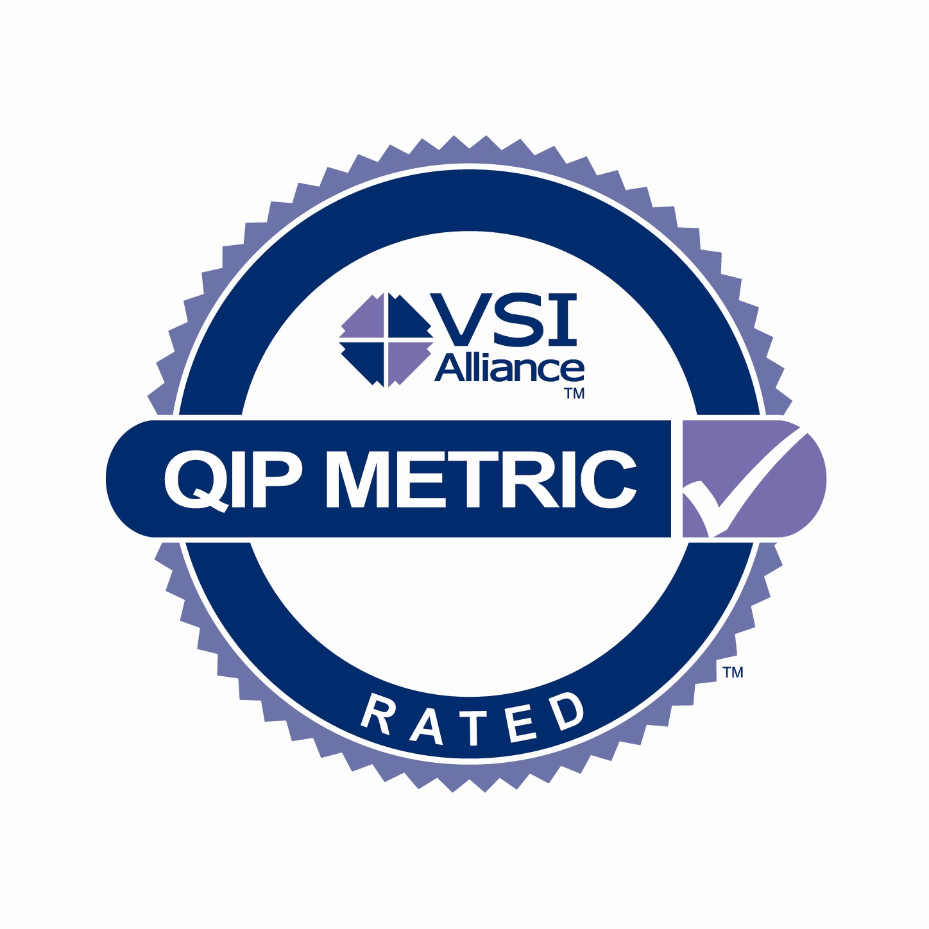
IP Users can take advantage of the QIP's capabilities in several ways. They can simply compare the total scores of similar products, or they can examine the QIP's metrics in detail, even on a question-by-question basis. They can even change the weighting of each question. This allows them to adapt the QIP to reflect their project's unique requirements. IP Users who adopt the QIP's ratings into their procurement system are eligible to display their own badge of quality commitment:
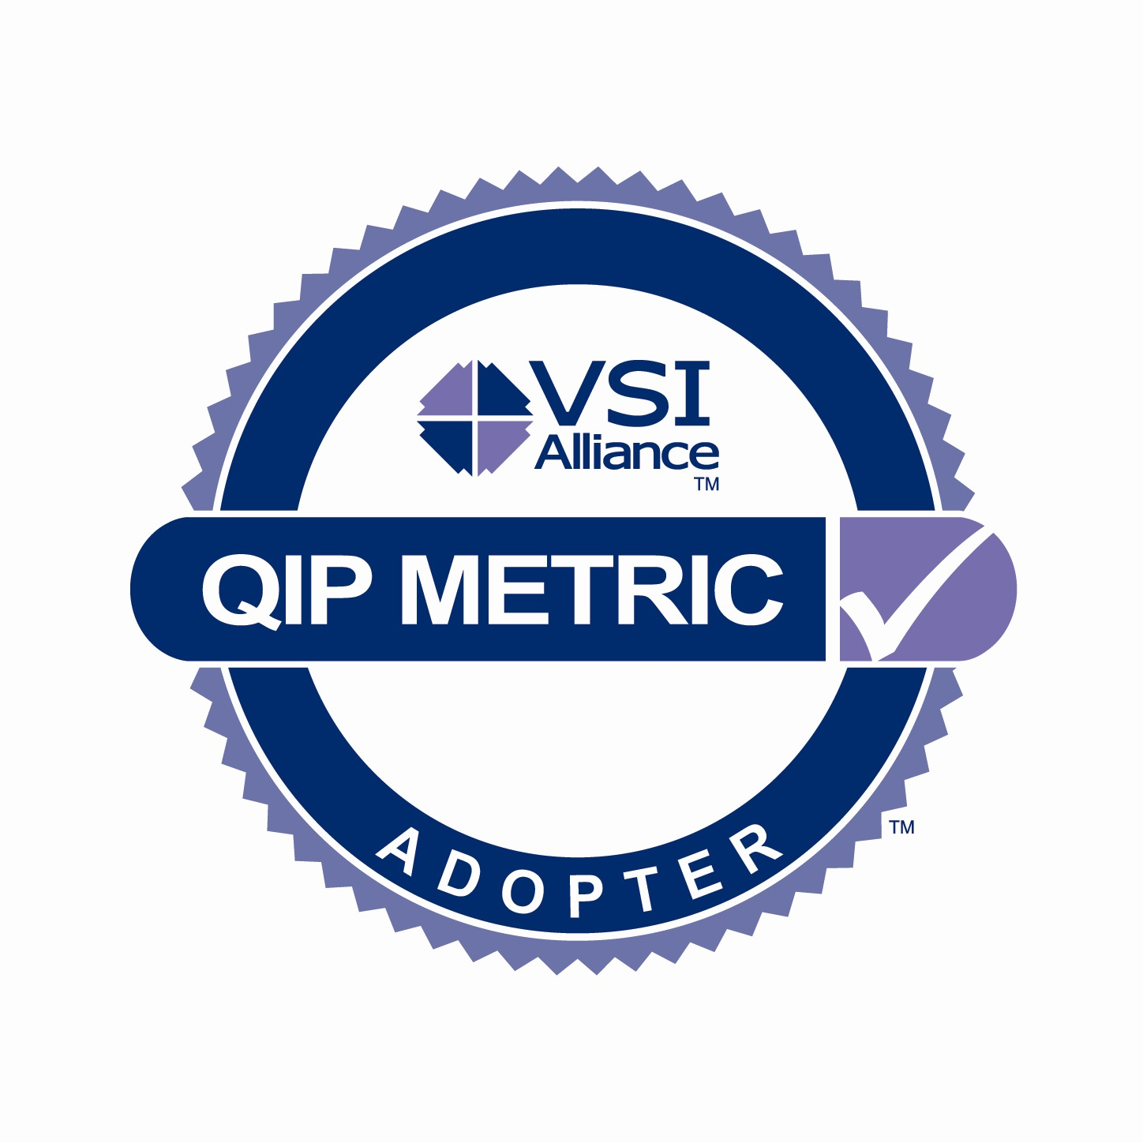
The QIP's virtual panel is very willing to work with its users, but we urge them to be careful. The standard QIP weights were determined by the panel's hundreds of projects of experience. IP Users would need to exactly change the weightings on each IP's QIP they are evaluating to keep the comparison's "apples" to "apples."

How do I start using the QIP?
That depends on you. If you prefer to jump in and just do it, then grab our Jump-Start section and get going. Since IP Users and IP Vendors will use the QIP differently, looking at both the IP Vendor and the IP User Jump-Starts will give you a rounder experience.
If you prefer to see and then do, take a look at the Jump-Start for basics, and then try our hands-on Walkthroughs.
If you are a person who likes to consider material from different perspectives, take a look at the Operator's Reference as well as the Jump-Start and Walkthrough sections.
Regardless of which path you take, you may find yourself with questions. You will find a link on each worksheet page for QIP "Technical Support." This will open an email for your questions or comments. We have also begun a Troubleshooting and FAQ section in this manual. It will be updated as necessary to address common questions and experiences.
Finally, there is other information that some will find useful, but others will find distracting. These facts are included in the Appendices.

Jump-Start
Ready for adventure? Already have, and know how to use, MS Excel? Just start using the QIP. For the first time through, keep it fictional. Change answers as you like. Get a feel for the metric. This will give you the tools you need to get serious later. It may also change the way you look at reuse. The QIP metric is a virtual expert, derived from real experience, which will play "what if" games all night long.
Note that “pop up” comments are available for many of the questions that provide added detail or clarification as to how the questions should be answered.

Jump-Start for IP Vendors

Step One: Get started.
Open a blank QIP spreadsheet. Enable macros. The QIP opens automatically on the Legal Notices worksheet. Good information, but not what you're looking for. Select the Summary worksheet from the tabs along the bottom of the Excel window.

Step Two: Fill in the basic information.
Make up a company. Name your IP. Note that as soon as you replace “VirtualComponentName,” a dialog box will open with a suggested filename. Save the renamed spreadsheet. Fill out the rest of the identifiers. All Excel conventions apply.

Step Three: Select the Vendor Assessment worksheet.
Go to cell B17. Select "Vendor & Integration." Now look at the tabs along the bottom. Select the "Vendor Assessment" worksheet.

Step Four: Answer the questions.
Note how colors change. Green is good. Orange/yellow is caution. Watch the score add up.

Step Five: Fill out another worksheet.
Next use the tabs at the base of the window to try "Soft IP Integration." Note how some answers can open or close other questions. Check out the colors. When you don't satisfy a highly ranked attribute (called an "Imperative") the scoring cell turns red for danger.

Step Six: Check your score
Return to the Summary worksheet. Note how the scores have changed. Go back to the component worksheets and see how changing your answers there will affect your overall score. If you change B17 on the Summary worksheet to "Vendor, Integration & Development," the "Soft IP Development" tab will appear. As you investigate the questions, consider how they reinforce good quality practices.

Jump-Start for IP User

Step One: Open a completed QIP spreadsheet.
Enable macros. If you don't have a real QIP available, follow the IP Vendors Jump-Start to create an example. Select the Summary worksheet. All Excel conventions apply.

Step Two: Examine the scores.
Start with the Scoring Summaries at the top of the page. The "traffic light" display shows red for danger, orange/yellow for caution, green for "go." Note the numbers in each category.
Next you will see the identifying information: the company, IP, and type. Experiment with the values for B17 to make sure that all relevant worksheet tabs appear at the bottom of the window.
Note the way the major scores are broken into categories in the lower half of the worksheet. Try changing the value for B18.

Step Three: Examine the component worksheets
Start exploring the other worksheets tabbed at the bottom of the window. Each worksheet has its own scoring summaries. Look for orange/yellow and red sections. Read the IP Vendor's comments. Consider the questions that were not satisfied. Look at the other questions that were satisfied. Imagine their effect on your own project development.

Step Four: Open a completed QIP for a competing IP.
Examine its score. Look through its component worksheets and consider the QIP attributes it did or did not satisfy. You are well on your way to making an informed judgment.

Walkthroughs
Here are two separate but related walkthroughs of using the QIP. If you follow these examples, you will see just about everything you need to use the QIP effectively.
The first is a guide for IP Vendors, who need to fill in QIP metrics for their IP products. The second is for the IP Users, who need to be able to interpret the scores on a QIP spreadsheet. We recommend that IP Users also look at the IP Vendor Walkthrough. It will give them a better understanding of how the QIP works. In either case, we assume that you already have a copy of Microsoft Excel and know how to use it.

Walkthrough for IP Vendors
In this walkthrough we will fill in a QIP for "Tuna," an imaginary digital soft communications IP from FloatingFish Development.

Start with a blank copy of the QIP metric.
- Go to the VSI QIP website (www.vsi.org ) and select the QIP vendor logo.
- Download the QIP metric spreadsheet, VSIA-QIP-v2.00 Beta.xls.
- Open the VSIA-QIP-v2.00 Beta.xls file.
- Enable Macros.
- Read the Legal Notices. If you agree, continue.

Set up a Vendor Template
- Select the "Summary" worksheet (highlighted in green) from the worksheet tabs along the bottom of the window.
- Select cell B14, which will hold the name of the IP Vendor.
- Type in "FloatingFish." (Yes, that is not the name of your company. But this is just a tutorial. When you sent up your real company template, we will assume you'll substitute the appropriate labels.)
- Save the file under a new name, such as "FloatingFish_template.xls." (Ignore the little man behind the curtain if he tells you that you have "unanswered questions." Save it anyway.).
- Note B16, the cell that sets the type of IP. Use the drop-down list. This is important because it tells the QIP which component worksheets you will need. We're using a digital soft IP for our example.
- Select cell B17, which tells the QIP the depth of assessment you wish to do. Note the tiny red triangle in the top right corner of the cell in column A. This describes the assessment types. Select “Vendor” from the drop down list in column B.
- Select the "Vendor Assessment" worksheet tab.
- Answer the questions on the worksheet. (It's just for practice, so be creative.)
  - Note the tiny red triangles in the top right corner of column B for some of the questions. Click on the question or simply pause your cursor there to see a clarifying note.
  - Your answers go in column C. Note that you can choose your answers from the dropdown menus in the cells.
  - The score for that question appears in column D. Note that they can be worth different numbers of points. Also note that running subtotals are kept for each category of questions (in pale green) and a running total for "Vendor Assessment" appears in pink at the top and bottom of the column.
  - Above the running total is a "traffic light" display. It provides a visual summation for the IP User. The traffic light clearly shows how many questions have been answered and whether or not the answers satisfied the best practice implied by the questions. The three classifications of questions are Imperatives, Rules and Guidelines. The color green, which shows the number of questions satisfied, signifies a positive response to the IP User. A yellow to orange color, which shows rules and guidelines not satisfied, indicates "Caution." Red, the number of Imperatives not satisfied, signals that they should "Stop" and carefully consider their options.
  - Type your own comments to the questions in column E. This gives you a chance to explain your answer.
  - Column F shows the classification of question. Remember that Imperatives are the most important, followed by Rules and then Guidelines.
- Go back and change some of your answers. See how the spreadsheet and scores change.
- Return to the Summary worksheet
- Note that the summary tables now reflect your answers on the Vendor Assessment worksheet.
- Save and close the file (even if it suggests you have "unanswered questions"). This file can be used as a template for all of FloatingFish Development's IP.

Fill out the IP Development Worksheet
- Reopen "FloatingFish_template.xls."
- Enable Macros and select the Summary tab.
- Select cell B15 and name the IP product. We'll use "Tuna." Note that QIP immediately suggests a new file name. We'll change it to "Tuna_devel.xls" for this tutorial.
- We will assume that Tuna is a digital soft IP. Otherwise we would go to cell B16 to select "Analog IP," "Verification IP," "Software IP," or "Mixed-Signal IP" as necessary.
- Select cell B17, which indicates the depth of assessment we will be doing. Select “Vendor, Integration & Development” from the drop-down list in column B. Note the information displayed on the summary page and the spreadsheet tabs are updated when we change the assessment type.
- Select the “Vendor Assessment” Worksheet tab. Note that this contains our answers from the previous section.
- Our next step is to select the "Soft IP Development" Worksheet tab.
  - We decided to fill out the "Development" section first because we, at the imaginary FloatingFish Development team, have used consistent development practices for all versions of Tuna. That will allow us to save time by using "Tuna_devel.xls" as a template for all the Tuna IP products.
- Note that the first question, "Is the IP configurable?" is classified as "Optional." in column F
  - Optional questions are a qualified exception to the question ranking we discussed earlier. Remember that Imperatives are the most important, followed by Rules and then Guidelines. Optional questions are more for information than scoring. They are not given a color. They usually, however, open or close sub-questions that may be Imperatives, Rules or Guidelines and will score points. If your product does not exercise that option then the now hidden questions are not held against it.
  - Try answering "y" for "yes." Then continue on to the next question. Answering "yes," that you do have examples, will earn 2 points.
  - But if you answer "no," then the follow-up question can not be answered. Many QIP subsections are interactive, opening or closing more questions depending on how you answer. Tabbing the questions makes these sections easy to spot.
  - If you have a slower computer, to give it a second or two to finish opening or closing sections. It won't accept a new answer until it is done.
  - Note that worksheet column "G" specifies the kind or deliverable to which the question refers.
- Answer the rest of the questions creatively.
  - Note that many subsections are interactive.
  - Note the different colors of question subheadings and their subtotals.
  - When you fail to satisfy an "Imperative" question, the score cell turns a "Traffic Light" red and the subsection's scoring cell will turn a "Something's wrong here" pink.
  - A few questions are not "yes" or "no." Instead, they are "always," "often," or "never."
  - Don't forget to pass the cursor over the questions with little red triangle at the upper right for clarifications.
- When finished, examine the section subtotals along with the final score for this worksheet and the "Traffic Light" summation of the results.
- Now go back and change some answers. Note how the spreadsheet interacts and the scores change.
- Save the worksheet.
- Return to the Summary Worksheet. Note Tuna's QIP score in progress appears both on top of the page and broken into the major subheadings toward the bottom of the page.
- Close the file.

Fill out the IP Integration Worksheet
- Reopen "Tuna_devel.xls."
- Enable Macros
- Select the Soft IP Integration worksheet tab.
- Continue answering the questions.
- When finished, again examine Tuna's score.
- Return to the Summary worksheet. Consider how Tuna's score has changed.
- In reality, you would probably begin rechecking your answers, perhaps adding comments to key individual answers.
- Congratulations, the QIP for the world-class Tuna Digital Soft IP is now complete and ready to share with the world. Save the worksheet as "Tuna_complete_QIP.xls. Our imaginary FloatingFish Development group would now make this QIP available to serious evaluators.

Walkthrough for IP Users
This will introduce you to opening, interpreting, and even customizing a filled-in QIP worksheet.

Open a completed QIP metric.
- If you have a completed QIP worksheet from the vendor, then open it. If not, you may wish to work through the IP Vendors tutorial to develop your own "Tuna_complete_QIP.xls" or simply open a blank QIP worksheet and pretend.
- Enable Macros.
- Read the Legal Notices.
- Select the Summary worksheet tab from the bottom of the spreadsheet window.

Examine the Summary Worksheet
- Look at the upper right corner of the spreadsheet.
  - It summarizes the IP overall scores. In this case our imaginary "Tuna" IP only scored 76% of the possible points.
Total | 76%
Imperatives not satisfied | 6
Rules & Guidelines not satisfied | 42
Satisfied Imperatives, Rules & Guidelines | 206
Unanswered | 21
Total | 275

  - It also lists the number of questions answered unsatisfactorily as a "Traffic Light" visual. The Imperatives, marked in red for "Danger," are the most important questions. (At a minimum, if this were a real product, you would want all Imperative questions satisfied.) The Rules and Guidelines that were not satisfied, which are marked in orange/yellow for "Caution," are of lesser importance. Questions that received satisfactory answers are marked in green for "Go."
  - The next boxes show the number of questions still unanswered (another problem with our imaginary vendor) and the actual total points scored by the Tuna IP on this worksheet.
- Move to B18. Select "Summary." The bottom of the Summary Worksheet now shows only the scores for the main worksheets and their primary sections.

 | Score | %
Vendor Assessment | 195 | 92%
VENDOR: Vendor Assessment | 195 | 92%
IP Integration Assessment | 431 | 74%
SOFT IP: IP Ease of Reuse | 293 | 76%
SOFT IP: Design & Verification Quality | 138 | 71%
IP Development Assessment | 346 | 74%
SOFT IP: IP Ease of Reuse | 72 | 95%
SOFT IP: Design & Verification Quality | 274 | 70%

- Return to B18. Select "By category." The table expands to show the next level of detail.

Vendor Assessment | 195 | 92%
VENDOR: Vendor Assessment | 195 | 92%
IP Integration Assessment | 862 | 74%
SOFT IP: IP Ease of Reuse | 293 | 76%
SOFT IP: IP Maturity Assessment | 15 | 100%
SOFT IP: Documentation Quality | 112 | 62%
SOFT IP: Ease of Integration | 166 | 88%
SOFT IP: Design & Verification Quality | 138 | 71%
SOFT IP: Design Quality: Design Detail | 78 | 68%
SOFT IP: Verification Quality | 60 | 75%
IP Development Assessment | 692 | 74%
SOFT IP: IP Ease of Reuse | 72 | 95%
SOFT IP: Ease of Integration | 72 | 95%
SOFT IP: Design & Verification Quality | 274 | 70%
SOFT IP: Design Quality: Internal IP Design Documentation | 30 | 67%
SOFT IP: Design Quality: Design Detail | 112 | 81%
SOFT IP: Verification Quality | 132 | 63%

  - Although you can now see how Tuna did in more detail, you still don't know where the big problems, the "Red Light" Imperatives, came from.
  - That will require a visit to the QIP's component worksheets.
- Select the "Soft IP Integration" Worksheet tab from the bottom of the Excel window.
- Look for "red lights" in the top of the page summary. They will show the number of times Tuna did not satisfy an Imperative on that worksheet.

 |  | Scoring Summaries
 | 76% | IP Ease of Reuse
 | 71% | Design & Verification Quality
 | 74% | Total
 | 5 | Imperatives not satisfied
 | 17 | Rules & Guidelines not satisfied
 | 70 | Satisfied Imperatives, Rules & Guidelines
 | 9 | Unanswered
 | 101 | Total

- Work down column D to see which specific questions were not answered satisfactorily (yellow or red cells) or skipped (clear). The ideal would be a steady flow of green lights.
- Look in column E to see if the IP Vendor explained why the IP failed this question or what they were doing to correct the deficiency.

n | 0 | The new documentation will correct this.

- Continue to open the relevant worksheets. Discover where else Tuna scores less than ideal and why.
- If this were a real product evaluation, you would compare Tuna's scores with the other IP you were considering.

Customizing the QIP for your project
You may decide that your particular situation will require reweighing the points on a number of questions. This should be done with caution and the altered spreadsheets renamed.
- Open a completed QIP (such as Tuna_complete_QIP.xls).
- Enable Macros. Select the Summary Worksheet tab.
- Rename the worksheet before you begin to alter anything (such as AltTuna_QIP.xls).
- Examine the individual questions on the individual worksheets.
- Select the questions that you wish to reweigh.
- Let's say, for whatever reason, you think where related combinational logic is placed could be a deal-breaker. "5" points doesn't seem strong enough.

Is related combinational logic placed together in the same module? | y | 5

- Simply select the column F cell, and select the weighting you wish, in this case changing from “Rule” to “Imperative”.
  - The new points appear, and all of the QIP's summary tables will update. There is, however, a serious trade-off.

Is related combinational logic placed together in the same module? | y | 10

  - The spreadsheet "AltTuna_QIP.xls is no longer standard. You can no longer compare its scores with scores from other, unaltered QIP spreadsheets.
  - To keep an "apples to apples" comparison going you would have to make "alt" versions of the QIP worksheets of all other IP you might compare for this project.
- Notate, save, and close all altered QIP files.

Operator's Reference
The Jump-Starts and Walkthroughs cover the heart of the program. This section adds notes, reflections, and details that did not fit within the earlier sections.

How does the QIP metric work?
The QIP carefully questions the IP Vendor about their quality practices. It then takes the answers and calculates quality assessment scores for the IP. When the IP User investigates possible IP for integration in their new SoC design, they can contrast the respective scores and make a clear "apples to apples" comparison on the quality axis.
QIP's engine is an integrated set of Microsoft Excel worksheets. The questions and calculations measure fitness for reuse of Digital Soft IP, Digital Verification IP, Software IP, and Analog Hard IP. Each component type has its own questions and its own assessment worksheet. The QIP assesses Mixed-Signal IP by linking the Digital IP and Analog IP questionnaires.
The worksheets are intelligently interactive. Answers open or close related subsections as required. Not all questions are given the same weight by the spreadsheets. Obviously some concerns are more important than others in objectifying the issues.
The questions themselves are the product of careful deliberation. Industry experts, assisted by working groups of IP users and developers, have decided what areas are critical and how they can be measured. Their questions are based on their real-world experiences.

The QIP follows standard MS Excel conventions.
The name you type in for the IP under examination (to replace “VirtualComponentName”) also creates the filename, so use only the characters a-z, 0-9 and _ (underscore). The NT File System is case insensitive so don't use upper-case (A-Z) to differentiate IP names. If that is not feasible, use the File/Save As command to create a file name.

Understanding scores
The Summary worksheet displays the QIP metric's assessment. This predicts: How reliable the vendor will be in the relationship; How efficient the IP will be to integrate into the user's design; and How mature or stable the IP development has been.
As the IP User, when you compare the scores of different IP, realize that you are grading on the curve. There may be many high scoring IPs to compare, one may stand out from the rest, or you may be in a yet murky area where all scores are "low." You can still assess which choice is most likely to be successful.

Vendor Assessment | 0%
IP Integration Assessment | 0%
IP Development Assessment | 0%
Total | 0%

Underlying Scores
Since the IP User may want to weigh the qualities differently depending on their needs, assessment metrics are also reported as their component measures. IP Integration, for example, is logically broken up into IP Ease of Reuse and IP Design & Verification Quality. Each of these major headings is broken into its parts.

IP Integration Assessment | 0
SOFT IP: IP Ease of Reuse | 0
SOFT IP: IP Maturity Assessment | 0
SOFT IP: Documentation Quality | 0
SOFT IP: Ease of Integration | 0
SOFT IP: Design & Verification Quality | 0
SOFT IP: Design Quality: Design Detail | 0
SOFT IP: Verification Quality | 0

Each of the separate worksheet pages that form the metric take the measures further down in detail, giving running totals for their own sets of questions. This can be especially useful for an IP User when deciding among a field of strong candidates. An IP Vendor can review the questions to see how the metric supports good practices. The more QIP identified quality practices vendors follow, the higher their vendor and IP quality assessment will rise.

Traffic Lights and Grades
The worksheets give a “traffic-light” representation that visually reinforces the scores. Green is good or "Go." Orange/yellow means "Caution;" consider the effect of this answer on your project. Red means "Danger" or even "Stop." An IP User should stop and think at every red light. Red is only used when an Imperative, the most important type of attribute, has not been satisfied.
Result totals, therefore, are given in order of importance. The unanswered questions total is also a consideration. It dilutes the metric's recommendations. That is why the number within the cell is shown in red, just below the "traffic lights."

Imperatives not satisfied | 0
Rules & Guidelines not satisfied | 0
Satisfied Imperatives, Rules & Guidelines | 0
Unanswered | 866
Total | 866

Keep in mind that even when all questions are answered, the QIP does not give a pass or fail grade. Only you as the IP User can make that decision. The QIP, however, is a very strong tool to help you to objectively contrast alternatives and make an informed decision.

Interactive Questions
As you work through the questions, you'll discover their interactive properties. When the cursor passes over a question, a comment may pop-up with more information. Assessment questions have drop-down lists with the only allowable answers (either y/n or always/often/never) presented. Scoring fields change into traffic light colors and write-in values as you go:

Does the IP include a reusable verification component such as an eVC, SystemC, Vera, C++ or similar verification component? | y | 2
Does the reusable verification component documentation clearly indicate the methods available for use within the verification component? | n | 0
Does the documentation describe how to use the verification components in an SoC verification environment? | n | 0
Can the verification component be extended to include additional functionality? | y | 2

Or

Does the IP include a reusable verification component such as an eVC, SystemC, Vera, C++ or similar verification component? | n | 0

Does the reusable verification component documentation clearly indicate the methods available for use within the verification component?

Does the documentation describe how to use the verification components in an SoC verification environment?

Can the verification component be extended to include additional functionality?

In effect, a red "Danger" cell indicates that the answer infers poor quality, and is likely to be considered unacceptable by an IP integrator. An orange/yellow "Caution" cell is not unacceptable. However, it indicates that the answer (and therefore the quality it infers) could be better. Only a green "Go" cell shows an acceptable answer for that attribute. The numbers of cells of each color are totaled and presented in the summaries.
IMPORTANT NOTE: To be of acceptable quality, an IP should meet all the Imperatives and not violate crucial rules. In other words, there should be no reds, and only a few orange/yellow "caution" lights. These conditions also reflect in the final metric scores; Imperatives are given the most weight, followed by Rules, and then by Guidelines. Therefore, higher scores indicate higher quality.

How scores add up

Total QIP Metric
The example below was taken from an earlier version of the metric, but it illustrates how points add up in the present version as well. Individual questions are given a score based on how they are answered and a maximum possible score. The maximum score is the value assigned to a “yes” or “always” answer. These two figures are then summed up for each Topic (green rows). The Topics are summed up into Areas of Concern (blue rows), which are then, in turn, summed up to the Views (pink rows). Questions that have been grayed out are discounted from both sets of sums. In this figure, the text for these questions is shown: in the actual spreadsheet, these would not be visible. You would have to visit the underlying worksheet to see the questions.
Also this figure shows the grouping by only displaying the header rows except for the one topic.
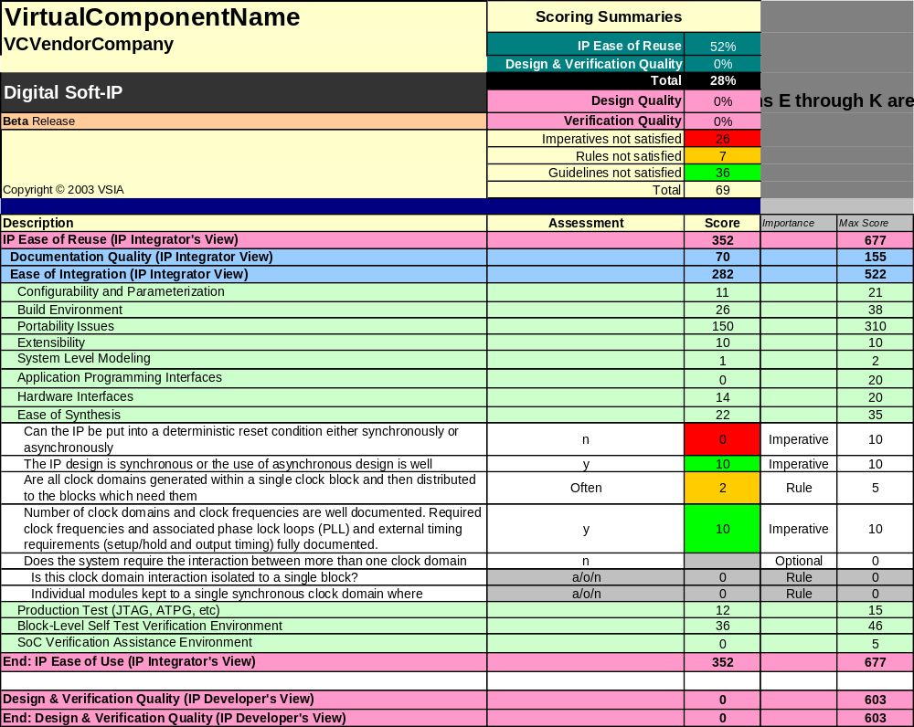

The results are copied to the summary sheet as below, and combined with the scores from the other relevant worksheets.

Summary Report | Total | 76%
Version 2.00 Beta
 | Imperatives not satisfied | 6
  ^{Technical Support}
 | Rules & Guidelines not satisfied | 42
 | Satisfied Imperatives, Rules & Guidelines | 206
 | Unanswered | 21
 | Total | 275
Type in the name of the IP Vendor | FloatingFish Development
Type in the name or part number of the IP | Tuna
Select the type of IP you are evaluating | digital soft IP
Select the type of assessment you are undertaking | Vendor, Integration & Development
Select the amount of information you wish to display | By category
 | Score | %
Vendor Assessment | 195 | 92%
VENDOR: Vendor Assessment | 195 | 92%
IP Integration Assessment | 862 | 74%
SOFT IP: IP Ease of Reuse | 293 | 76%
SOFT IP: IP Maturity Assessment | 15 | 100%
SOFT IP: Documentation Quality | 112 | 62%
SOFT IP: Ease of Integration | 166 | 88%
SOFT IP: Design & Verification Quality | 138 | 71%
SOFT IP: Design Quality: Design Detail | 78 | 68%
SOFT IP: Verification Quality | 60 | 75%
IP Development Assessment | 692 | 74%
SOFT IP: IP Ease of Reuse | 72 | 95%
SOFT IP: Ease of Integration | 72 | 95%
SOFT IP: Design & Verification Quality | 274 | 70%
SOFT IP: Design Quality: Internal IP Design Documentation | 30 | 67%
SOFT IP: Design Quality: Design Detail | 112 | 81%
SOFT IP: Verification Quality | 132 | 63%

An alternate explanation of the Traffic Light Display
In the worksheet example above, the number of cells of each color is displayed in the traffic light view in the worksheet summary. This displays the number of attributes that are unacceptable, the number that add significant risk to successful and timely integration, and those which are acceptable.

Saving the results
Use standard Excel file output utilities. If you took advantage of the Save As dialog offered when the IP name was entered, then you can use the File->Save command. Otherwise use File->Save As to avoid overwriting the template spreadsheet.

Troubleshooting and FAQ

Excel Compatibility or Why won't it run on my computer?
The spreadsheet was developed using Microsoft Excel 2003 and validated on Excel 2002. It has not been validated with previous versions of Excel.

Macros or It still won't run on my computer?
Make sure that you have enabled Excel macros. Otherwise QIP will not run.

Type of IP or Why can't I evaluate more than one type of IP?
Look at the Summary worksheet. What value do you have for B16, "Select the type of IP you are evaluating"? The choices are "analog IP," "digital soft IP," "verification IP," "soft IP," and "mixed-signal IP." Once the QIP knows what kind of IP you are examining, it will make the right worksheets tabs available along the bottom of the window.

Type of assessment or Why can't I see the Integration worksheet? or Why can't I see the Verification worksheet?
Look at the Summary worksheet. What value do you have for B17, "Select the type of assessment you are undertaking"? The choices are "Vendor," "Vendor & Integration," and "Vendor, Integration & Verification." Once the QIP knows what depth you would like, it's more than happy to show the right worksheet tabs along the bottom of the window.

I don’t understand the question or How do I answer the question?
“Pop up” comments are available for many of the questions that provide added detail or clarification as to how the questions should be answered. Simply place your mouse over the questions that have a red triangle in the upper right corner. Additional information about the question will appear.

I have more questions than you have answers or How can I contact tech support?
I'm just the manual; I don't mind you going over my head. The VSIA Quality Support Pillar has made that very easy by including a link on each worksheet page: “Technical Support.” Look for it in column A. Selecting it will open an email form for questions or comments. We look forward to hearing from you.

Appendixes

Referenced Documents
Ref No | Document Title and Document Number
[01] | QIP Quality Metric – Excel Spreadsheet  File: VSIA-QIP-v2.00 Beta.xls

