ECE545 REPORT

Cemin Zhang

- 5GHz LNA Design

- 2.4GHz OSC

- VCO Design Using Varactor

- VCO With Buffer

- Mixer Single Balanced

- 5GHz LNA Design

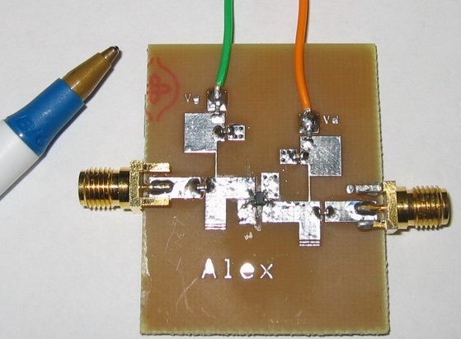

Noise Figure (Simulation)：
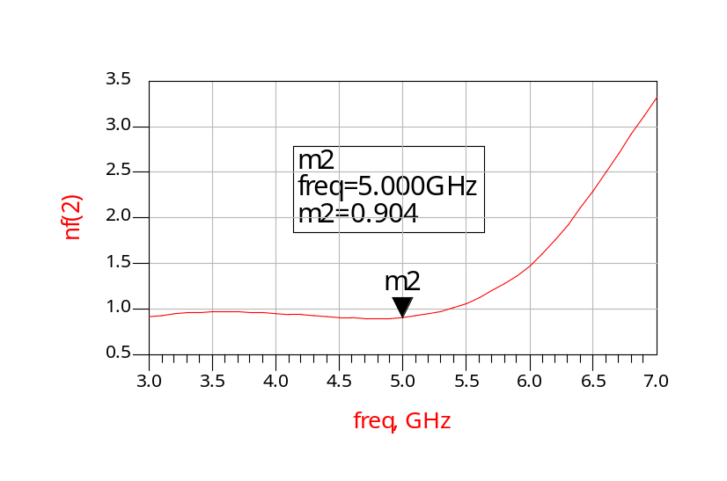
Comparison of [S] : Simulation(left) and Measurement(right)
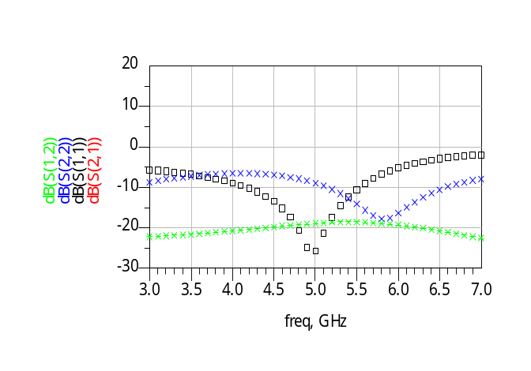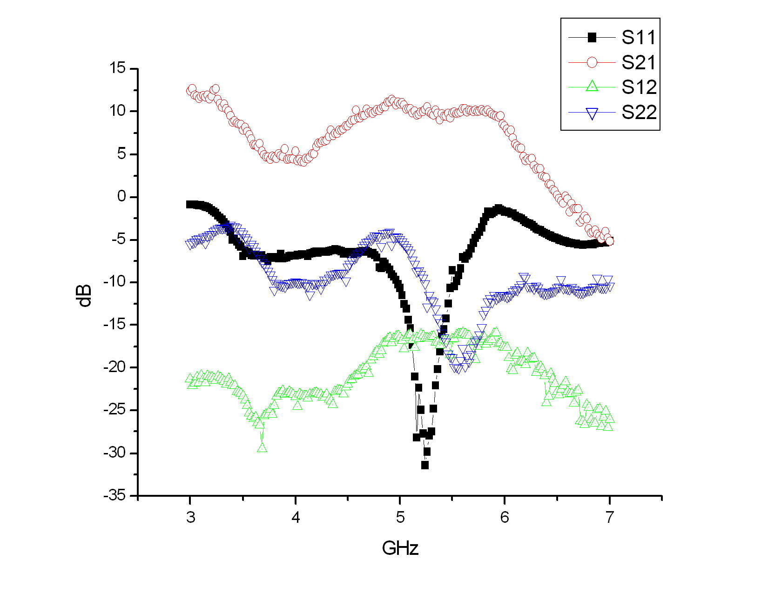
- 2.4GHz OSC

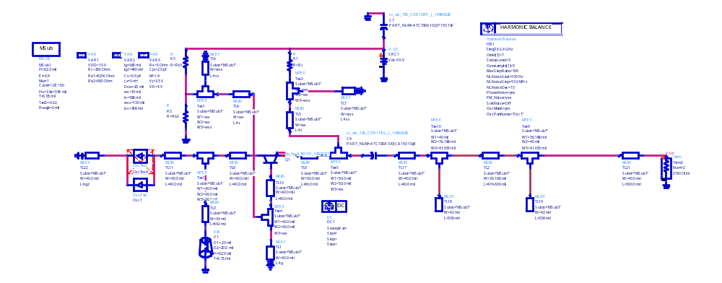

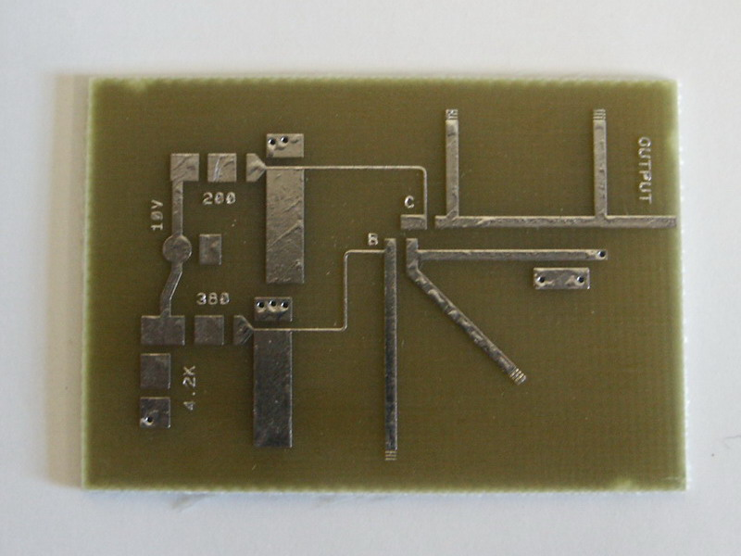
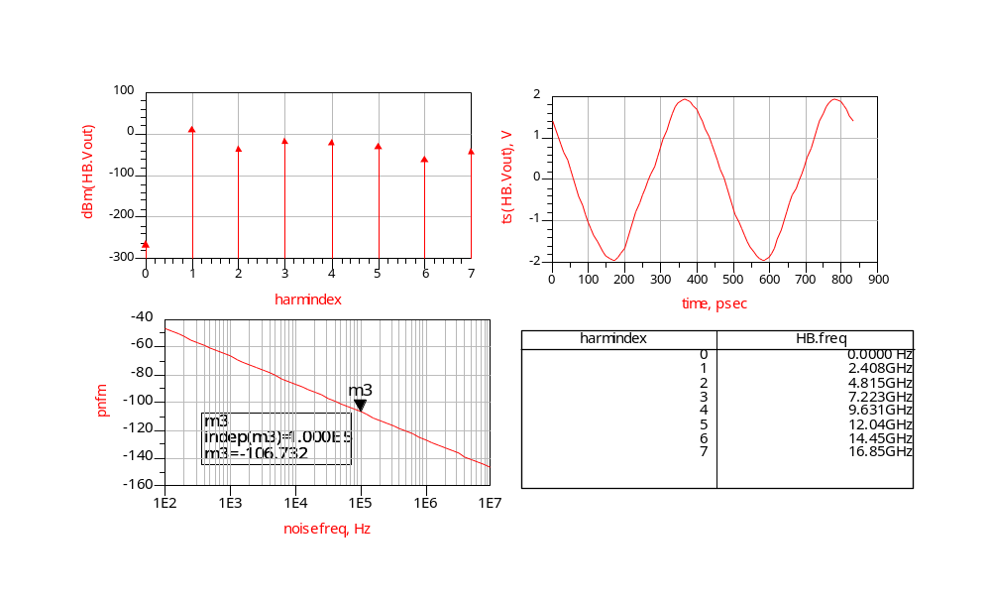
Simulation results show the Voltage output in Frequency and Time domain. The OSC frequency is adjusted 2.408GHz, the simulated phase noise is -107dBc@100kHz.

III. VCO Design Using Varactor

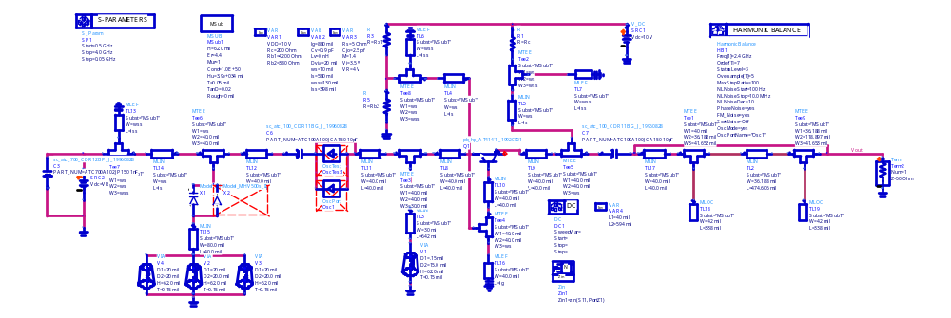

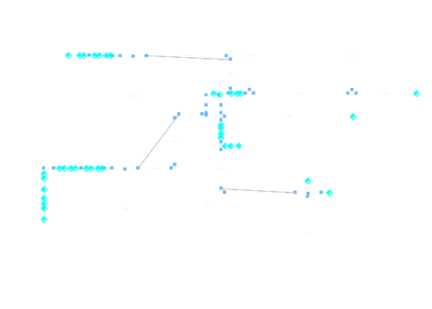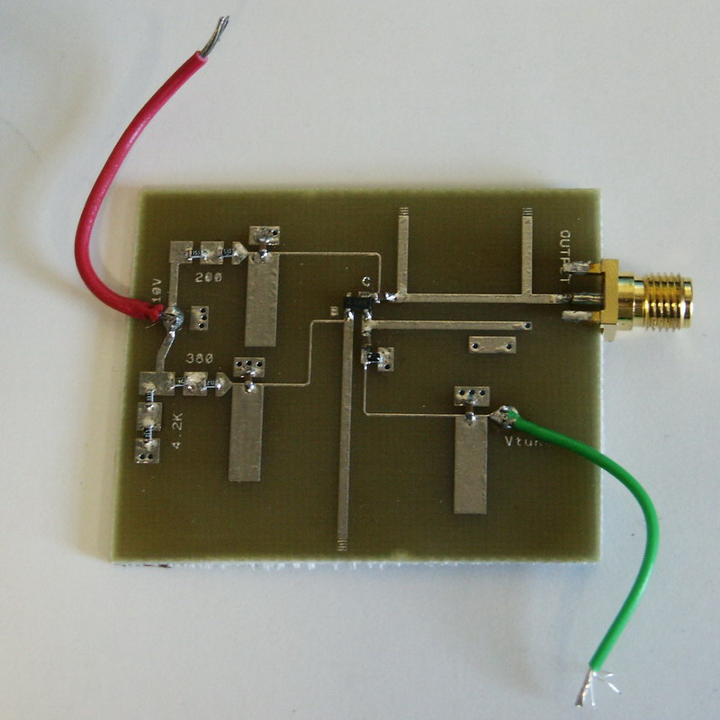
Varactor is the units from MicroMetrics, SMT package. Sample units are at hand.
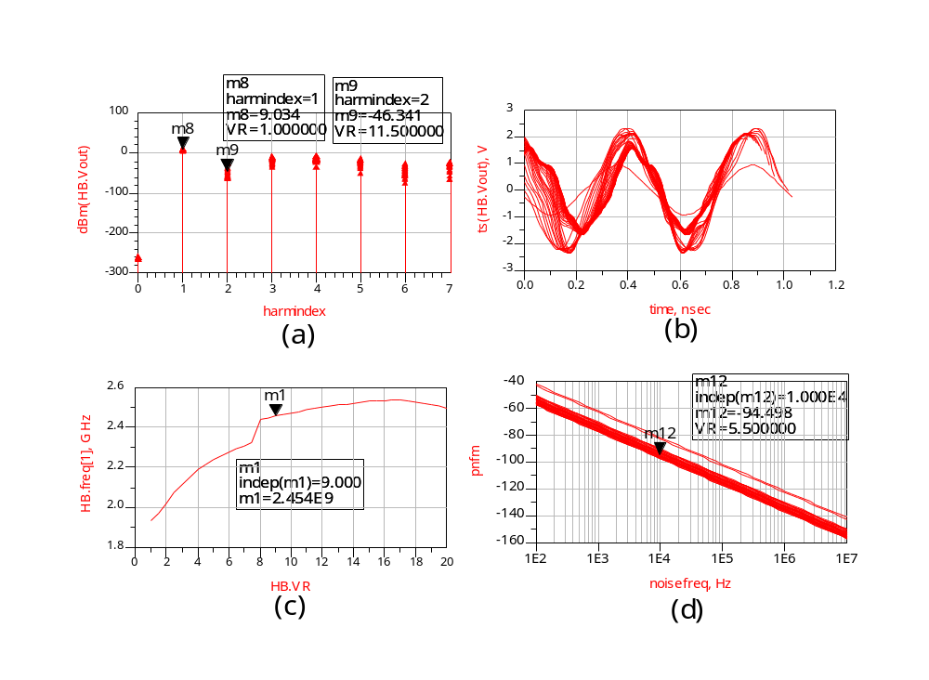
(C) shows the frequency output response as the relationship with the tuning voltage: 1.9GHz – 2.5GHz, 1V-20V; (a) (b) (d) show the output in frequency and time domain and the phase noise performance -95dBc@10kHz
VCO Measurement Results

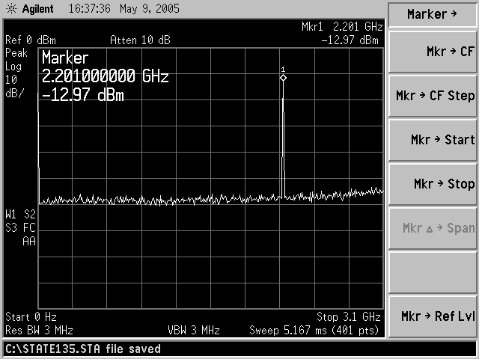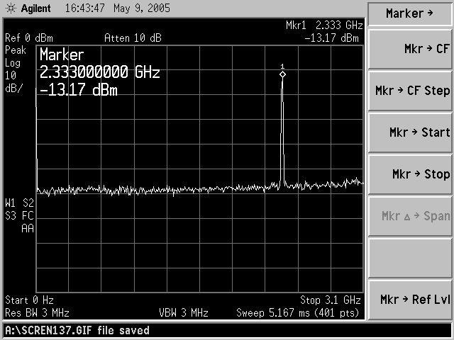
(a) (b)

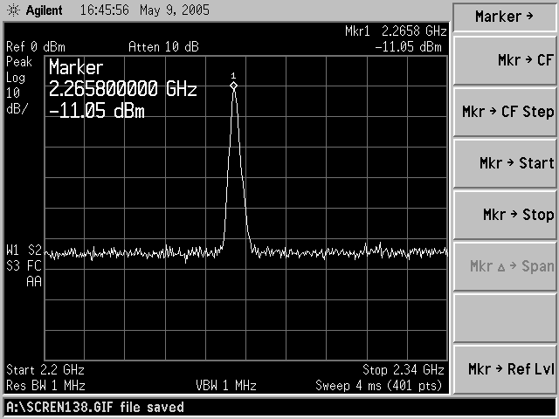
(c)

The plot (a) and (b) show that the frequency range of VCO is from 2.2GHz to 2.33GHz, with tuning voltage from 3V(2.2GHz) to 12V(2.33GHz).

Plot (c) shows the detail of the VCO output with tuning voltage at 5V, and the oscillation frequency is 2.265GHz.

Output power is low here because:
When I increase the bias voltage, some kind of low frequency harmonics will appear. While I keep increasing the bias, the transistor will be burned.

I will try to figure out how to solve this problem.
VI. VCO With Buffer

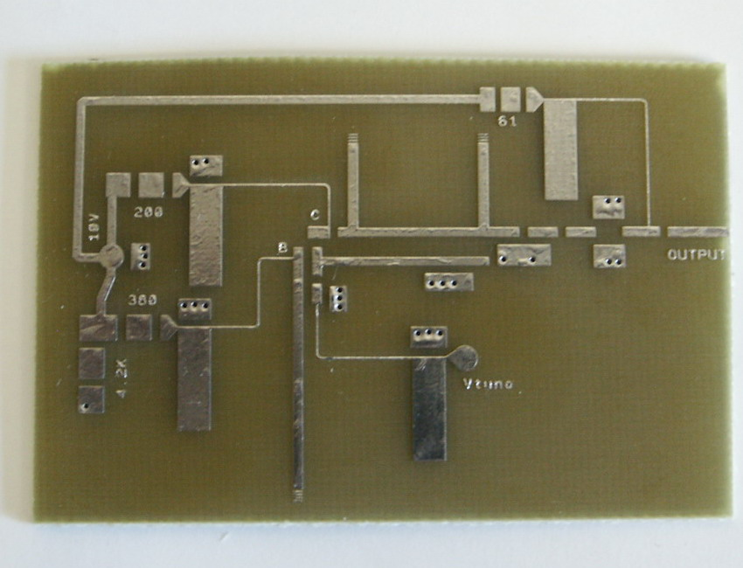
Buffer

Performance is similar with Part III design, but have good isolation between load and VCO, and has adjustable output power.

V. Single Balanced Mixer Design

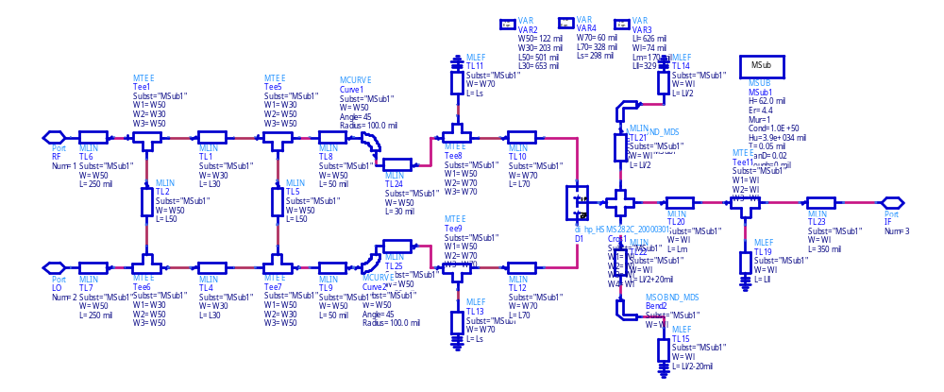


RF: 2.45 GHz (-10dBm)
LO: 2.35 GHz

IF: 100 MHz 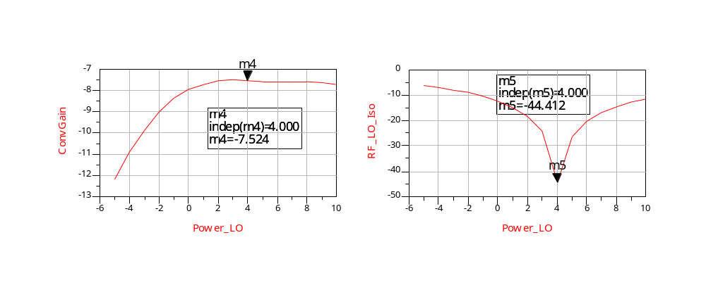

Conversion Gain VS. PLO : ILmin @ PLO=4dBm Isolation (RF-LO port) VS LO Power
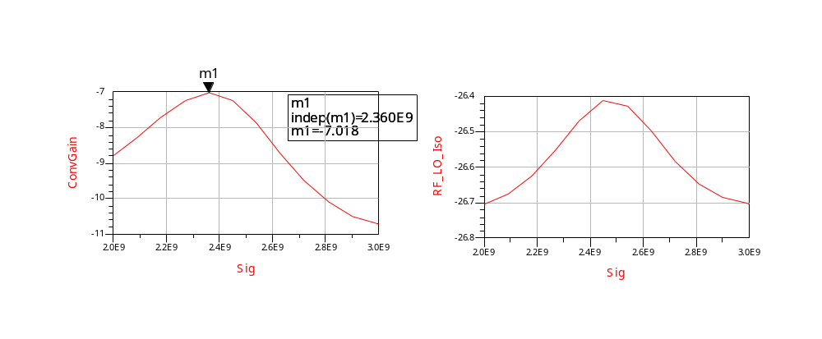
Conversion Gain VS. RF : ILmin @ RF=2.36GHz Isolation (RF-LO port) VS. RF Freqency
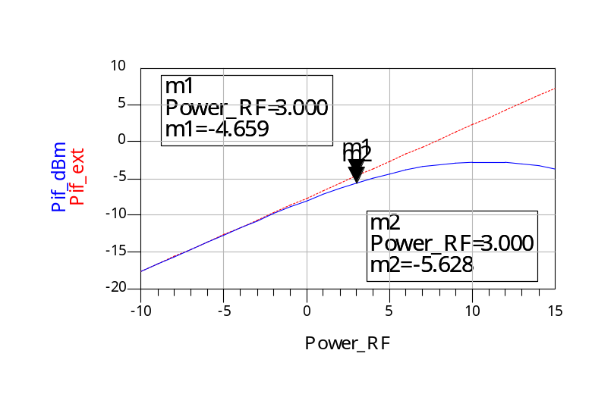
P1dB point when PRF=3dBm, so RF power input to the Mixer should be < 3dBm
Mixer Measurement Results

Based on the simulation results, I choose the value below during the measurement:
RF: 2.45GHz, -10dBm
LO: 2.35GHz, 4dBm

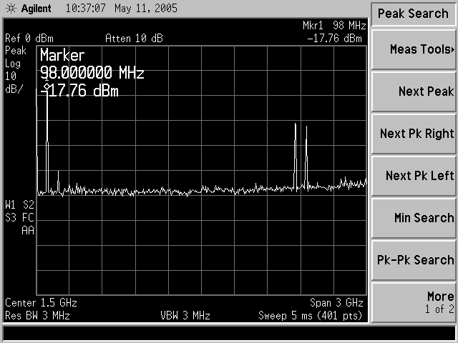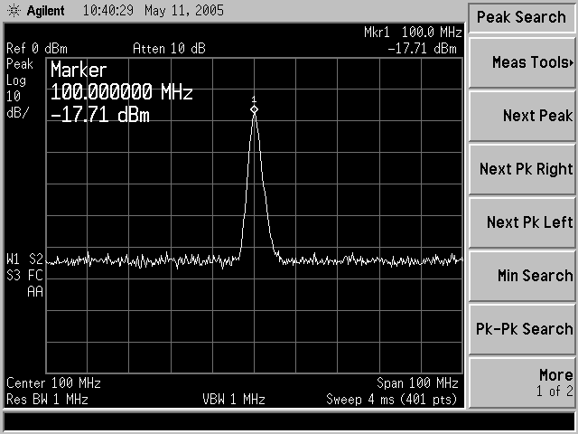
(a) (b)

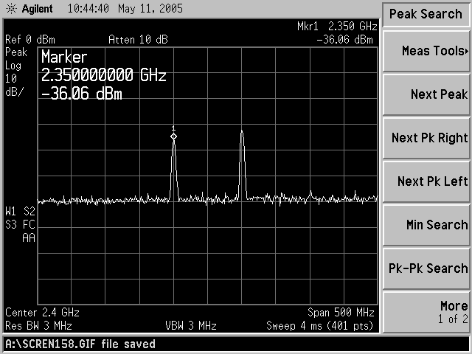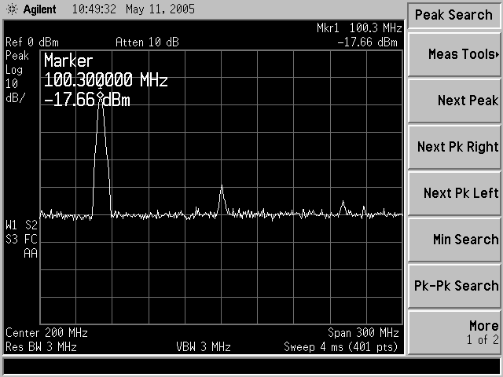
(c) (d)

- Figure (a) shows IF signal, with the RF and LO leakage at IF output port. The conversion gain is -7.7dB, which is very close to the simulation result(-7.56dB)
- Figure (b) shows the detail of IF output signal
- Figure (c) shows LO and RF leakage at IF port, the LO at IF port is -36dBm, which means the LO to IF isolation is -40dB
- Figure (d) shows the IF harmonics, the 2nd harmonics (200MHz) is -50dBm

