University of Tennessee – Knoxville
Introduction to Computer Networks - ECE 453 Fall 2006
Project 1

Home Network and Network Cable Construction

Austin Albright
aalbrig1@utk.edu

September 19, 2006

Task 1: Make an Ethernet cable yourself.
You are required to make the cable within 20-minute period of time in FH422 (the networking lab). The TA will be there to check you out. You can gather as many references as you can prior to the checkout. The checkout time is Sep. 11, 13, 18 (10:00am-12:00pm).
Report: Write a 1 to 2 page report describing the following:
- What are the pros and cons between twisted pair and coaxial cable? What kind of application use which media?
- So far, how many different twisted pair technologies have been implemented with what kind of bandwidth?
- Which of the 8 pins of RJ45 are for transmission and which are for receiving? And which pins are connected to which color-coded wire?
Twisted pair wiring dominants the local area network (LAN) field, as well as being the material used to form the local loops of the telephone system. Twisted pair wiring is used in industrial applications to allow automated assembly line machines to communicate to one another as well as their status to the human controllers. It is used for all sorts of small-scale applications such as connecting security system sensors, digital thermostats to the furnace/air conditioning unit it controls, etc. But by far if twisted pair is known world-round as the wiring used in computer networks. It is so widely used because it has the advantage of being relatively inexpensive (when you consider the price of the material versus the capabilities it provides). Twisted pair does suffer from higher noise and interference due to its lack of shielding. Also, in large installations the shear weight of the wiring can be an issue. Table 1 lists all the unshielded twisted pair (UTP) wire standards that have been in use or are in the finalization phase prior to becoming a standard. Of these only Cat-3, Cat-5e, and Cat-6 are still officially recognized by the TIA/EIA standards. For completeness sake it should be mentioned that the Cat-7 standard, which should handle data rates up to10Gbps, will probable use shielded twisted pair (STP) to limit alien-noise crosstalk [1].

Table 1. Unshielded Twisted Pair Technologies and Their Bandwidths
Type | Bandwidth
Cat-1 | N/A, no bandwidth rating, used  for voice or very slow data only
Cat-2 | 1MHz
Cat-3 | 10MHz
Cat-4 | 20MHz
Cat-5 | 100MHz
Cat-5e | 125MHz
Cat-6 | 250MHz
Cat-7 | 600MHz

Coaxial cable (coax) is capable of providing 1GHz of usable bandwidth, well beyond that of normal twisted pair wiring. Coax also has superior noise and interference immunity, compared to twisted pair, due to its shielding. Coax cable is extensively used in the cable television industry because of its high bandwidth and relatively low price compared to fiber optics. Coax in a network environment is problematic since coax is a broadcast (bus) media. By that I mean a message is sent to every user via the “bus” regardless of which individual user it was specifically for. This wastes a substantial amount of bandwidth and time of the users who the message was not “addressed” to. Also if a new user is to be added to the bus the line must be cut and a T added. This disrupts service for everyone on the bus. Twisted pair does not have this problem because it utilizes a switch to direct specific messages to just the intended recipient and a new user can be simple plugged in to any unoccupied port on the switch without effecting any other users. Twisted pair cable and coax cable have there own unique advantages and disadvantages as discussed so far. It is up to the user to select the correct one for their application. To cement this idea with a final example of these differences consider the distance between “nodes” of a network. Using twisted pair the maximum length of a single cable is 100 meters. But this is dependent on the maximum data rate and the “cat” rating of the twisted pair e.g. the IEEE 802.3 working group on 10Gbps twisted pair networking hopes to achieve 100m runs using Cat-7, but using Cat-6 the max run is only 30m [2]. Coax cable is capable of runs up to 500m when using thicker cable (RG-8) or 200m for thin coax cable (RG-58).

The pin assignments used in network connectors is defined by the Telecommunications Industry Association/Electronic Industries Association in the TIA/EIA-568-x standards. The predominate wiring/pin assignment is 568-B. By wiring one end of a patch cable in 568-B and the other in 568-A you can create a crossover cable which when connected between to computers directly will allow them to communicate without a router or switch or hub.

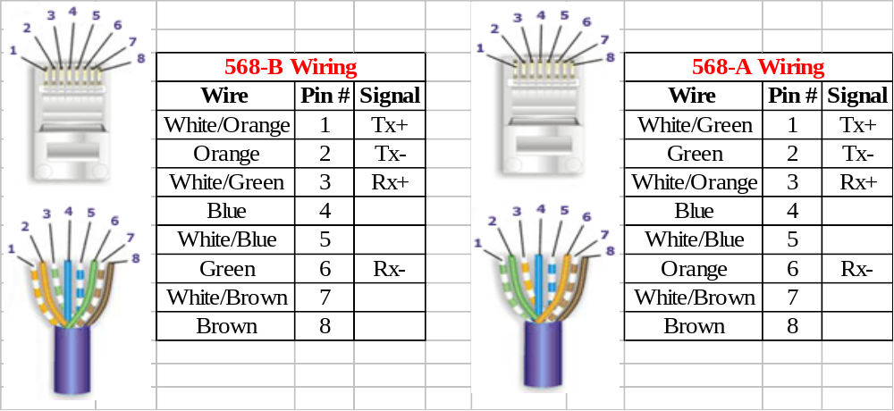Figure 1. Wire-to-pin diagram with pin numbers and signal assigned to the pin by the TIA/EIA. Plug and wire picture from http://www.lanshack.com/make-cat5E.aspx .

Task 2: Design a Home Network

Assumptions:
- There are two laptops (with built-in network card and wireless card, 2 USB ports, built-in modem), one desktop (with modem only), and one printer in the house. (Note that the operating system installed on these computers shouldn't affect your design. The assumption is that if the design works under windows, it SHOULD work under Linux as well.)
- The house has one telephone line.
- The house has cable TV.
Requirement: Design a home network such that multiple users can access the Internet and the printer at the same time.
- Budget: initial setup should cost no more than $350 (not including monthly fees)
- Easy to construct (that is, not much reorganization of the house needs to be made)
- A downstream data rate of at least 1 Mbps (in theory)
Report: By following your design in the report, a customer can actually build the network within one week including the time to order the parts. Your report should also provide convincing arguments why you choose this specific setup.
To create a home network that will provide all three computers the ability to connect simultaneously to the Internet as well as share the printer and files among the three computers several things must be considered. First how fast do you want to be able to transfer data on the local area network (LAN)? Second, how fast do you want to be able to transfer data on the wide area network (WAN) i.e. Internet. Thirdly, how much do you want to spend a setup the network and how much do you want to pay a month for Internet service. In our case we will not include any monthly fees, except those related to the modem, since we assume the home already has cable TV and phone service, and limit the setup (hardware and provider installation fees) to a maximum of $350 dollars total.

The first thing to find out is what Internet services are available for your home. In Knoxville, TN there are two options for high speed Internet, DSL or cable Internet. Using my home as the location I was able to find that cable Internet was available and the fees break down as shown in the following tables.

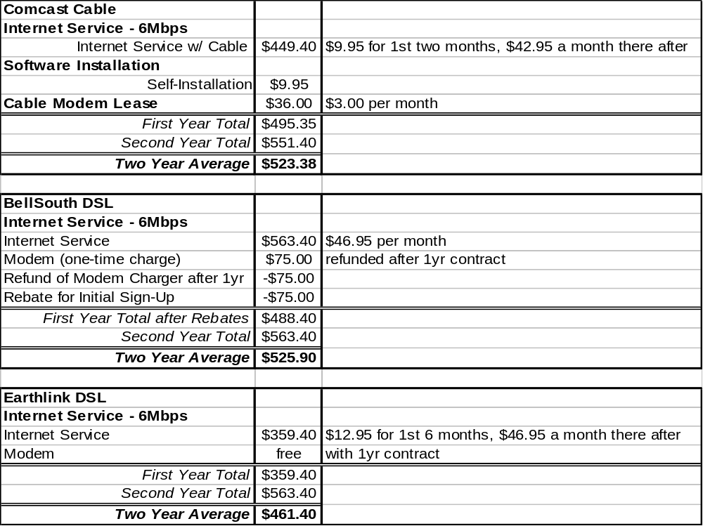

So it seems in my case that whether I keep the broadband service for one year or two the 6Mpbs DSL service from Earthlink is the best deal. With no equipment charges, a free modem, no installation charges (it is self-installation of the software and DSL filters on the phone jacks used for telephone service)

The desktop PC needs a network card added to it in order to connect it to the network. At this point in the technological advances in networking we can safely pick any PCI networking card. So you could pick a network card up at Wally-World as long as it was a PCI card and supported 10/100 network, which they all do you’d have to look in an “antique” store to find a 10Mpbs only card (little sarcasm there folks.) I found a 10/100/1000 Mbps PCI network card by Linksys that is compatible with Windows 98 to XP, as well as Linux driver kernels 2.2.x and 2.4.x. It sells for a $10.99 at newegg.com (a reputable online retailer).

To provide both wired and wireless networking, I have selected the D-Link DI-824VUP router/gateway. I have chosen the DI-824 because it offers four 10/100 LAN ports, one 10/100 WAN port, one USB printer port, one Parallel port, and one Com port. In addition to these wired port is provides 802.11b and 802.11g wireless networking. For us this means that we can have the desktop PC connected to via a standard network cable and have the freedom provided by the wireless portion to use the two laptops anywhere in the home that is within range of the signal (maximum indoor range is 328 feet, but varies based on topography of your home i.e. walls, multi-floor house, proximity to microwave oven, etc). If for any reason you wanted the increased speed of using a wired connection you can simple use a network cable to connect the laptop to the 10/100 switch. All three computers can be connected via cables with one port to spare. It also has a built in print server for a single printer using either a standard parallel printer cable or the increasingly more common USB printer cable. There is also a port for connecting a dial-up modem to the router, which can be used as a back-up Internet connection if the broadband connection was unavailable. So now that you have heard my sales pitch behind the advantage of the dual access feature of the DI-824 (wired and wireless), there is still a suite of reasons that make this router/gateway a good choice. These features are the hardware firewall/security features incorporated in the DI-824. It provides protection from denial of service (DoS) attacks, and unsolicited packets using stateful packet inspection (SPI). It also has domain blocking, IP filtering, MAC filtering, network address translation (NAT) with virtual private network (VPN) tunnels. These functions are performed in hardware and just provide one more layer of protection between the wild-west computer world that is a high speed 24/7 Internet connection. The wireless access can be protected using 64-bit, 128-bit, or 256-bit wired equivalent privacy (WEP) or wi-fi protected access (WPA) or WPA- pre-shared key (WPA-PSK).

So using the DI-824 from D-Link we can connect all the computers to the Internet, secure the wireless access to our network, and have some built in basic security between our network and the Internet. At the time of this writing the D-Link DI-824VUP was available from newegg.com for $119.99, which is the same place we’re getting the network card from so we’ll save on shipping.

Once the network card and router arrive and Earthlink has done their thing and mailed the modem and the filters for the telephones your ready to go. First, install the PCI network card in the desktop. The card probable came with illustrated instructions on how to insert the card, but if it doesn’t you can take a look here http://www.dur.ac.uk/its/services/network/lan/install_network_card/ for a simple step by step with sketches and here http://www.inf.aber.ac.uk/stunet/FAQ/Install_NIC.asp#Desktop for some really good color pictures (but with so-so directions.) To setup the modem you will need to connect DSL filters between all you telephones and the wall jacks. Then plug in the DI-824 and the modem from Earthlink, connect a telephone cable without a filter from the wall jacket to the DSL modem. Now follow the directions in the Quick Install Guide included with the DI-824 (also available online at http://www.dlink.com/products/support.asp?pid=274&sec=1#quickInstallGuides ). An example network diagram showing the layout of the modem, router, and computers is shown below.
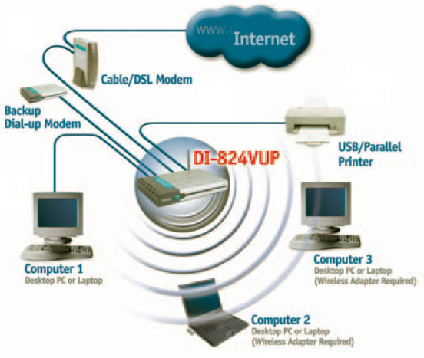
Example network layout from DI-824 manual.

I found the quick start guide to be excellent with numerous useful figures and diagrams. Rather than copying the entire guide in to this document, I’ll just supplement it with comments and improvements. The first of which is to update the firmware on the DI-824. Do this before you do anything else. You can do this via the nice web interface for administrating the router and by following the directions in the user’s manual. Once you update the firmware you will now be able to do the rest of the setup. So go back to the quick setup guide and follow the steps till step 4 page 8, where you have the option to clone the MAC address. This is a personal choice, but I do not suggest doing this. This provides you one tiny bit of anonymity for your local network, since this way the only possible MAC address visible will be that of the modem instead of your network router. Now go ahead and pick back up with the rest of the steps till you get to the wireless setup, step 4 page 10. If you updated the firmware like you should have you will have several new options for wireless security. You should either select the 256-bit WEP or WPA-PSK. You will need to come up with a key that will allow only the computers you give the key to access your wireless network. Also I would use WPA-PSK, since it has recently been show that WEP encryption can be broken in less than five minutes using freely available software from the Internet. Write down this key somewhere safe since a good key is at least 25 characters and includes at least one non-letter ASCII character e.g. !, @, #, ~, =, 1, 2, 5, etc. You may want to look up diceware, which is a method for picking a security phrase that is difficult to break, http://world.std.com/~reinhold/diceware.html . To connect the laptops via wireless you will need to tell them to connect to the wireless network and then entire the key you have made-up, created, whatever. If you have a problem getting the computers to connect you probable need to turn on “Obtain an IP address automatically” the Windows XP dialog for this is shown below, and is reached by viewing the properties of you local network connection and then highlighting the “Internet Protocol (TCP/IP)” and clicking properties.

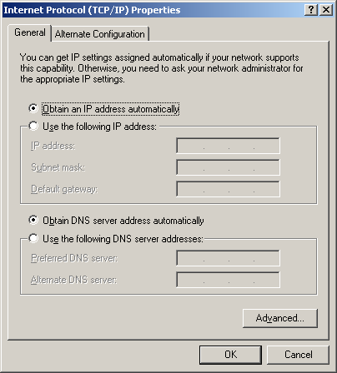
Windows XP dialog where automatic IP addressing can be turned on.

Almost all computers are set to obtain their IP address automatically by default regardless of whether you have previously connected them to the Internet or a LAN.

Conclusion
At this point you should have at least a home network and high-speed Internet access. Your downstream speed from the Internet will be 6 Mbps. Your minimum LAN transfer rate will be 100 Mbps for wired connections and 54 Mbps for wireless connections. Your printer will also be accessible to all the computers connected to your LAN, so long as you remember to install the printer driver on the computers that have never been used with your printer before. Finally, your total estimated cost for hardware, software, and installation comes to $148.09 including tax and shipping (UPS guaranteed 3-day ground service). Enjoy!
References & Web Links

[1] ANSI/NEMA Standards Publication No. WC 66-2001
Performance Standard for Category 6 and Category 7 100-Ohm Shielded and Unshielded Twisted Pair Cables

[2] Scott Powell, “Feasibility Study for 10G Over 100m Cat 7 and <100m UTP Feasibility Study for 10G Over 100m Cat 7 and <100m UTP” Sept 2003, URL:
http://www.ieee802.org/3/10GBT/public/sep03/powell_1_0903.pdf , Accessed 9-19-2006

Link to Linksys LKG-6100 PCI network card
http://www.newegg.com/Product/Product.asp?Item=N82E16833117203

Link to D-Link DI-824VUP at newegg.com
http://www.newegg.com/Product/Product.asp?DEPA=0&Item=N82E16833127132

