Lab #1 - Voltage Regulation of a Single Phase Transformer
ECE 325 - Electric Energy System Components
Instructor: Dr. Kai Sun
Lab TA’s: Denis Osipov and Wenyun Ju

Objective:
The objective of this lab is to correlate the calculated voltage regulation of a single phase transformer with the regulation observed in the laboratory, and also to make general observations about transformers.
Pre-lab:
The laboratory transformer is to be used as a 220/110 volt transformer (see Figure 1). The series impedance, referred to the 220 volt side, is approximately (24+j12) Ω.
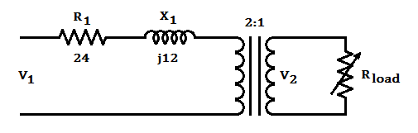
Figure 1
- State the voltage and current relationships of an ideal transformer.
- List some reasons why real world transformers are not ideal.
- Define voltage regulation.
- Assuming a purely resistive load, calculate and plot the relationship between secondary terminal voltage (V₂) and secondary current (I₂) for a 220 volt primary voltage (V₁) and a maximum secondary current (I₂) of 2 amps.
- Draw a circuit diagram showing how the relationship between secondary voltage and current can be measured in the laboratory. Indicate sources, variable load, voltmeters, and ammeters.
Lab Exercise:
- Connect the circuit from the Lab # 1 Wiring Diagram.
- Record enough readings of V₂ and I₂ to compare with calculated values.
Calculations and Comparisons:
- Compare the experimental and calculated results.
- Calculate the voltage regulation.
- Why was the excitation branch not included in the calculations? Did neglecting this excitation branch cause any problems?
Lab #1 Wiring Diagram:
