XHTML Forms

Web forms, much like the analogous paper forms, allow the user to provide input. This input is typically sent to a server for processing. Forms can be used to submit data (e.g., placing an order for a product) or retrieve data (e.g., using a search engine). There are two parts to a form: the user interface, and a script to process the input and ultimately do something meaningful with it. This document explains how to create the form’s user interface. The mechanics for processing form data – specifically with PHP – will be covered later in the course.

Form syntax
A form has three main components: the form element, form widgets (e.g., text boxes and menus), and a submit button. The form element has two required attributes – method and action.

<form method="post" action="script.url">
...
</form>

All form elements, also known as widgets, have a name attribute that uniquely identifies them. The data is sent to the server as name-value pairs, where the name is the input element’s name and value is that input element’s value. We will discuss later how this value can be used by the script.

Submission method
The method attribute specifies how data should be sent to the server. The get method encodes the form data into the URL. Suppose a form has two input elements with the names name1 and name2 with respective values value1 and value2. The get method would send a URL of the form script.url?name1=value1&name2=value2. The post method will not include the form data encoded into the URL. The post method is considered more secure because the get method allows a hacker to bypass the form by calling the script directly and passing an arbitrarily encoded URL string, which could contain invalid values. NOTE: If the form values contain non-ASCII characters or the form content of the URL exceeds 100 characters, the post method must be used.

Submission action
The action attribute specifies the script that will process the data. The value for this attribute is typically a CGI script or some other type of Web-based script, such as a PHP script. The get method is typically used when the script does not modify any state information on the server side, such as when a database query is performed. The post method is typically used if the script does modify any state information, such as making an update to a database.

Selection widgets
Selection widgets allow a user to select one or more items from a constrained set of choices. Selection widgets should always be preferred over text input widgets when the number of constrained choices is a manageable number. If the number of constrained choices is small enough so that they can all be visually displayed, such as a person’s gender, then radio buttons or check boxes should be used. If the number of constrained choices is large enough that it is infeasible to display them all, such as the states in the United States, then a menu is a good choice.

Radio buttons
A radio button is a form widget that allows the user to choose only one of a predefined set of items. When the user selects a radio button, any previously selected radio button in the same group is deselected. To create a radio button, use the input element with radio as the type attribute’s value, specify a name using the name attribute, and provide a value using the value attribute. All radio buttons that have the same value for the name attribute are considered a group. The value provided to the name attribute will be the name used in the name-value pair that gets passed to the script. To make one of the radio buttons be the default selection, set the checked attribute for that button to the value “checked”.

<p>Username: <input type="text" name="uname" /></p>
<p>How would you rate your skill in programming?<br />
<input type="radio" name="skill" value="beg" />Beginner
<input type="radio" name="skill" value="int" />Intermediate
<input type="radio" name="skill" value="adv" />Advanced
<input type="radio" name="skill" value="sup" />Super-hacker</p>
<p>How many hours do you spend programming each week?<br />
<input type="radio" name="hours" value="beg" />0-10<br />
<input type="radio" name="hours" value="int" checked="checked" />11-20<br />
<input type="radio" name="hours" value="adv" />21-30<br />
<input type="radio" name="hours" value="sup" />30+</p>

This is how the markup may appear in the browser.

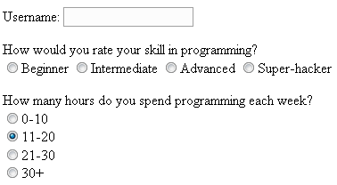

Note that the labels displayed next to the radio buttons are not the values of the value attributes. The value attribute’s content is what will be sent to the server; the label/description is provided within the page text. Also note that the first group of radio buttons does not have a radio button selected. To ensure that a selection is made, use the checked attribute as shown in the example. If no radio button in a group is selected, that group’s name-value pair will not be sent to the server, meaning that the input element will be undefined within the script that processes the form data.

Checkboxes
A checkbox is a form widget that allows the user to make multiple selections from a number of items. To create a checkbox, use the input element, specify checkbox as the type, specify a name using the name attribute, and provide a value using the value attribute. As with radio buttons, all checkboxes that have the same value for the name attribute are considered a group. You may pre-select one or more checkboxes using the checked attribute.

<p>Username: <input type="text" name="username" /></p>
<p>What programming languages have you used?<br />
<input type="checkbox" name="proglang" value="c" />C
<input type="checkbox" name="proglang" value="cplusplus" />C++
<input type="checkbox" name="proglang" value="java" />Java
<input type="checkbox" name="proglang" value="perl" />Perl
<input type="checkbox" name="proglang" value="perl" />Python</p>
<p>I agree to...<br />
<input type="checkbox" name="cheaplabor" value="yes" checked="checked" />work for $1.50/hour.<br />
<input type="checkbox" name="longdays" value="yes" checked="checked" />work 12 hours per day.<br />
<input type="checkbox" name="late" value="yes" />show up late every day.<br />
<input type="checkbox" name="usecomments" value="yes" checked="checked" />comment my code.<br /></p>

Here’s how the markup may appear in the browser.

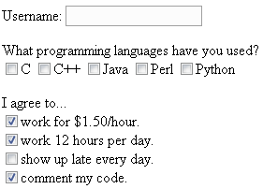

Suppose the checkboxes corresponding to “C”, “Java”, and “Perl” were selected in the above example. Three name-value pairs would be sent to the server: proglang=c, proglang=java, and proglang=perl.

Menus
A menu is a form widget that allows the user to select one (or possibly multiple) of several predefined values. Menus are useful in situations where displaying all of the values hinders page readability. Suppose you want the user to select their state of residence. One method is to make numerous radio buttons; the alternative is to use a menu.

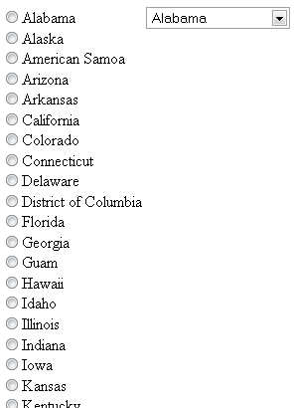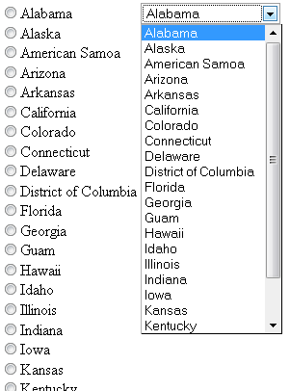

The example output on the left demonstrates how the menu hides all but the first choice, whereas all of the choices are displayed when using radio buttons. The example output on the right shows the expansion of the menu widget and the addition of scroll bars to further minimize the “real estate” occupied by the menu items.

To create a menu, use the select element to specify a name using the name attribute. The two optional attributes size and multiple control the display and functionality of the menu respectively. The size attribute specifies the desired height (in lines) of the menu. The multiple attribute allows the user to select more than one menu option (usually with the Control key for PCs and Command key for Macintoshes). The menu items themselves are created using the option element, which has a required value attribute. The text for the menu item is specified between the start- and end-tags for the option element. To have a menu item selected by default, use the selected attribute.

<select name="state">
<option value="al">Alabama</option>
<option value="ak">Alaska</option>
<option value="as">American Samoa</option>
<option value="az">Arizona</option>
<option value="ar">Arkansas</option>
<option value="ca">California</option>
...
</select>

The following markup demonstrates the size and multiple attributes of the select element as well as the selected attribute for the option element.

<select name="state" size="5" multiple="multiple">
<option value="al">Alabama</option>
<option value="ak">Alaska</option>
<option value="as">American Samoa</option>
<option value="az">Arizona</option>
<option value="ar">Arkansas</option>
<option value="ca" selected="selected">California</option>
...
</select>
Here is how the markup may appear in the browser. The example output on the left shows a menu with five options displayed simultaneously, with California already selected as the default choice. The example output on the right shows a menu with multiple (non-contiguous) choices selected.

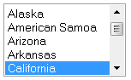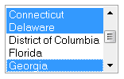

Most Web browsers support grouping menu items into categories. To create a group menu, use the optgroup element, specifying the name of the category with the label attribute. Next, make the desired menu choices (option elements) children of the optgroup element.

<select name="state" size="10">
<optgroup label="Pacific">
<option value="ak">Alaska</option>
<option value="ca">California</option>
<option value="hi">Hawaii</option>
<option value="or">Oregon</option>
<option value="wa">Washington</option>
</optgroup>
<optgroup label="West">
<option value="az">Arizona</option>
<option value="co">Colorado</option>
…
</select>

Here is how the output may appear in the browser.

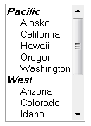

Text input widgets
Text input widgets are used to input one or more strings of text. They can have either a specialized purpose, such as submitting a password, or a generic purpose, such as entering a free-form line of text.

Text boxes
Text boxes contain one line of free-form text, and are typically used when the input is not derived from a constrained set of values. For example, text boxes are good choices for names or addresses, because it is impossible to predict in advance the name or address that will be entered by a user. To create a text box, use the input element, specify text as the type attribute’s value, and name the text box using the name attribute.

<p>Username: <input type="text" name="username" /></p>
<p>Nickname: <input type="text" name="nickname" /></p>

This is how the markup may appear in the browser.

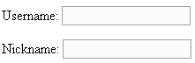

Three optional elements control how the text box appears. The value attribute specifies the default text that should be shown when the text box is displayed. This text will be sent to the server if the user does not modify it. The size attribute specifies the width of the text box measured in characters. The maxlength attribute specifies the maximum number of characters that can be entered in the text box.

<p>Username: <input type="text" name="username" /></p>
<p>Nickname: <input type="text" name="nickname" /></p>
<p>Favorite book: <input type="text" name="favbook" size="60"
value="The Hitchhiker's Guide to the Galaxy" /></p>
<p>I bet you can't type &quot;The quick brown fox jumped over the lazy dog&quot;!<br />
<input type="text" name="pangram" maxlength="12" /></p>

This is how the markup may appear in the browser. NOTE: The text in the last text box was entered to demonstrate that no more than twelve characters could be entered.

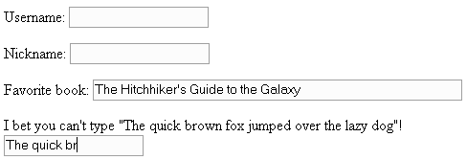

A few things to note about text boxes:
- The default width is twenty characters (e.g., size="20").
- The default value for a text box is the empty string (e.g., value=""). Unlike a radio button that sends nothing to the server if it is not selected, the text box will send the empty string to the server.

Password boxes
Password boxes can be used to visually mask confidential data, such as passwords, from casual observers. Password boxes are identical to text boxes, except that whatever is typed into a password box is masked by bullets or asterisks. To create a password box, use the input element, specify password as the type attribute’s value, and name the password box using the name attribute.

<p>Username: <input type="text" name="uname" /></p>
<p>Password: <input type="password" name="passwd" /></p>

Here is how the markup may be displayed in the browser.

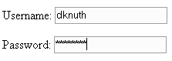

As with text boxes, password boxes also support the size, maxlength, and value attributes; however, having a predefined value for a password box defeats the purpose of having a password at all. It is also important to note that password boxes do not provide any encryption, so it is possible for the password to be intercepted when the form data is sent to the server unless a secure connection is used (i.e., HTTPS). The primary purpose of the password box is to visually protect the text string.

Text areas
Text areas allow the user to provide more than one line of textual input. Text areas can be as wide as the page itself, and the browser will add scroll bars if the text provided by the user exceeds the size of the text area. To create a text area, use the textarea element, specify the number of rows and columns using the rows and cols attributes, and name the text area using the name attribute. Default text can be specified by placing it between the textarea begin- and end-tags.

<p>Username: <input type="text" name="username" /></p>
<textarea name="comments" rows="2" cols="30">Default text</textarea>
<textarea name="comments" rows="5" cols="40"></textarea>

This is how the markup may appear in the browser. NOTE: The text in the text area was added to demonstrate that scroll bars are added if the input text exceeds the size of the text area.

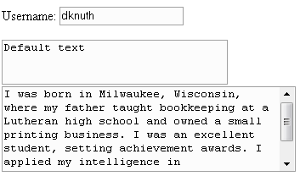

Hidden fields
A hidden field is a form component that allows name/value pairs to be specified without any visual representation. The hidden name/value pairs will be sent to the server for processing just like the pairs corresponding to the other form widgets. To create a hidden field, use the input element, specify hidden as the type attribute’s value, and provide values for both the name and value attributes.

<input type="hidden" name="pageid" value="x3g9kf43" />

Hidden fields can be specified anywhere within the form start- and end-tags.

Hidden fields are useful for providing context. For example, suppose you have (1) a Web page with a form that facilitates removing records from a database, and (2) a script to process the name/value pairs and perform the deletion. Instead of simply assuming the user’s choice of records to delete is correct, a confirmation page should be displayed prompting the user to confirm the deletion. The processing script can be set up so that it looks for a specific name/value pair – for example, confirmdelete="yes". If the form is lacking this pair, the script can generate the XHTML, which includes the hidden field <input name="confirmdelete" value="yes" />, for the confirmation page. When the user submits the form data from the confirmation page, the “confirm deletion” pair will exist, meaning that the record deletion should take place.

Submitting and resetting forms
Form data is submitted to the server when the user clicks on a submit button widget. NOTE: There are other methods for submitting form data without using a button widget; however, they are beyond the scope of this document. To create a submit button, use the input element, specify submit as the type attribute’s value, and provide a label for the button widget via the value attribute.

<input type="submit" value="Let's Go!" />

This is how the markup may appear in the browser.

The name attribute is optional for the submit button. Suppose you have a Web page with two separate forms corresponding to creating an account and signing in using an existing account. The first form might have fields for address information, desired username, and password. The second form will likely only have two text boxes: username and password. The first form’s submit button may be marked up as <input type="submit" name="newacct" value="Create Account" />. The second form’s submit button may be marked up as <input type="submit" name="signin" value="Sign In" />. The script on the server can simply check for the existence of newacct or signin to determine the next course of action.

A typical companion to the submit button widget is the reset button widget, which resets a form to its original state (i.e., default values). To create a reset button, use the input element, specify reset as the type attribute’s value, and provide a label for the button widget via the value attribute.

<input type="reset" value="Start Over" />

This is how the markup may appear in the browser.

To create a submit or reset button with an image, use the button element with an img child element. The type, name, and value attributes for the button element should either be submit or reset depending on the desired action.

<button type="submit" name="submit" value="submit">
<img src="letsgo.gif" alt="Submit form data" />
</button>

This is how the markup may appear in the browser.

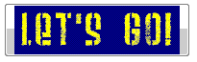

Organizing form content

Legends
Things.

Labels
Things.

Tab order
Things.

Keyboard shortcuts
Things.

Protecting form content

Disabling elements
Things.

Read-only elements
Things.

