Development of a Web-based Screening Tool for Ground Source Heat Pump Applications

Xiaobing Liu Jason DeGraw Mini Malhotra Wes Forman Mark Adams Gina Accawi Brett Brass Niraj Kunwar Joshua New

ABSTRACT

The ground source heat pump (GSHP) technology has great potential to help the nation meet its energy and decarbonization goals, but consideration of these systems has been blocked by several barriers. One important barrier is the lack of a coherent toolset for feasibility analysis. The economic viability of a GSHP application is affected by many factors. but current design and analysis methods do not work well and require significant expertise to apply, even for high-level feasibility analysis. While building energy modeling has become more and more important in the design of buildings, the tooling around GSHP modeling and simulation has not kept up with the times. The tools available are not easy to use and most energy modelers lack the experience and expertise needed. As a result, potential users of this technology are making uninformed decisions (either implicitly or explicitly) with respect to this technology. A web-based free-to-use tool is being developed for quick techno-economic analysis of GSHP applications in nearly any building in the US. This tool is enabled by improvements in the calculation methodology to allow rapid sizing of borehole configurations that give significant first cost savings, lowering one of the significant barriers to system implementation. The screening tool currently uses the DOE prototype building models and an extended g-function library to size ground heat exchangers and simulate the performance of GSHP systems for various commercial and residential buildings in most climate zones in the US. A drawback of this prototype-based approach is that it is rather a “one size fits all” approach with respect to the building details. To address this shortcoming, the team is in the process of integrating with ORNL’s AutoBEM to automatically create a building model based on user inputs including footprint, height, function, and age of the building. AutoBEM adopts DOE prototype building model parameters to fill other inputs based on the age and function of the simulated building. This paper introduces the structure, components, features, and results of the web-based screening tool for GSHP applications. Future directions for further developing the tool are also discussed.

INTRODUCTION

The ground-source heat pump (GSHP) is a proven technology that can efficiently keep homes and businesses thermally comfortable year-round. However, the application of GSHP is hindered by its high initial cost, mostly due to the cost of drilling boreholes in the ground for installing ground heat exchangers (GHE) (Liu et al. 2019). Most people make decisions on whether to install a GSHP system based on economics. A public-facing tool that can accurately analyze the costs and benefits of investing in GSHPs will be able to help identify GSHP projects with favorable economics.

However, the needed tool does not yet exist. Most existing tools are dedicated to sizing the GHE, which is the most unique and critical component of a GSHP system (GLHEPro 2016, Gaia 2016, BLOCON 2017). These GHE sizing tools rely on inputs of the thermal loads of the GHE, which must be estimated or calculated with other methods or programs. Also, these dedicated GHE sizing tools do not account for the interactions among various components of a GSHP system, so they cannot accurately predict the performance of a GSHP system. For example, a pumping control or outdoor air ventilation system can affect the thermal loads and the efficiency of a GSHP system so the operation of the building should be accounted for when designing a ground heat exchanger. The lack of a tool possessing such functionality presents a major hurdle preventing GSHP market penetration and novel financing models, such as third-party ownership of GSHP systems. The feasibility of installing a GSHP system for a specific project is usually assessed based on “rules of thumb” to estimate the equipment capacity required to meet the heating and cooling loads of the building and the size of the GHE. This rough estimation often results in a GSHP system that does not meet the economic expectations of the owner or a GSHP system that does not perform as efficiently as it could.

The size and cost of a GHE are sensitive to the amount of energy rejected to the ground when cooling compared with the amount of energy extracted when heating. Given the large thermal mass of the ground, the heat transfer process of a GHE is almost completely transient, and thus both the peak and the total thermal loads of a GHE need to be accounted for when sizing a GHE. The thermal loads are affected by the design and operation of the building and its mechanical system. As buildings become more complex due to the increasing diversity in functions and efforts to reduce the environmental footprint of buildings, building energy simulation (BES) is more commonly used to predict the thermal loads of a building. Integrating BES with the GHE design tool not only provides a seamless transition between the building’s thermal loads and the GHE sizing but also, more importantly, allows the user to assess the effects on the GHE size and the GSHP system performance resulting from variations in the design and operation of the building and its mechanical system (Liu and Hellström 2006). With a side-by-side comparison between a GSHP system and a conventional HVAC system that serves the same building, the energy savings and carbon emission reductions resulting from using the GSHP system can be evaluated. Furthermore, an integrated tool enables a simulation-based holistic design approach for driving down the overall cost and energy consumption of the building by improving the design and controls of the building and the GSHP system.

The bottleneck of the simulation-based design approach is building a detailed and accurate BES model to predict thermal loads. This work is time-consuming and requires many inputs. Having access to a software package that can estimate hourly thermal loads with minimal user input will be beneficial. Additionally, GHE sizing tools should be improved to allow highly customizable designs of the GHE so that the GHE performance can be optimized based on the given thermal loads and the constraints of the available land area for installing the GHE.

The goal of this project is to develop a web-based and user-friendly techno-economic analysis tool for quickly assessing the viability of applying GSHP for a given residential or commercial building. This tool is based on EnergyPlus and OpenStudio (NREL 2020), the US Department of Energy’s (DOE’s) flagship program in BES, and the latest development in GHE modeling, which can quickly simulate the performance of highly customized GHE designs with satisfactory accuracy (Spitler et al. 2020 and 2021). The project will initially consider systems in which the GHE is expected to meet the majority of the thermal load and the hybrid configuration, which uses a combination of GHE and conventional heat rejection/addition equipment may be included in the future.

This paper reviews the implementation of a web-based GSHP screening tool, including an automated process for creating GSHP system simulation and sizing GHE within a given rectangular land area; the interfaces of the web-based screening tool; and examples of the screening results of GSHP applications in 16 prototype commercial buildings in the 15 climate zones in the US.

Methodology

The three components of the GSHP screening tool include (1) an auto-sizing tool for vertical bore ground heat exchanger (VBGHE), which allows highly customized borehole field patterns; (2) a seamless approach to integrating the state-of-the-art BES programs, EnergyPlus and OpenStudio, with the advanced VBGHE sizing tool; and (3) a user-friendly interface to accept user inputs, display key simulation results, and perform economic analysis based on the cost data of HVAC equipment and energy prices.

The auto-sizing tool of the VBGHE has been developed and integrated with an OpenStudio Workflow to establish a fully automated process for replacing an existing HVAC system sub-model in a BES model with a GSHP system, sizing each component of the GSHP system, including the VBGHE, and simulating the performance of the GSHP system. A web interface has also been developed to take users’ inputs and display screening results from an automated design and economic analysis process. The structure and data flow of the automated process is shown in Figure 1.

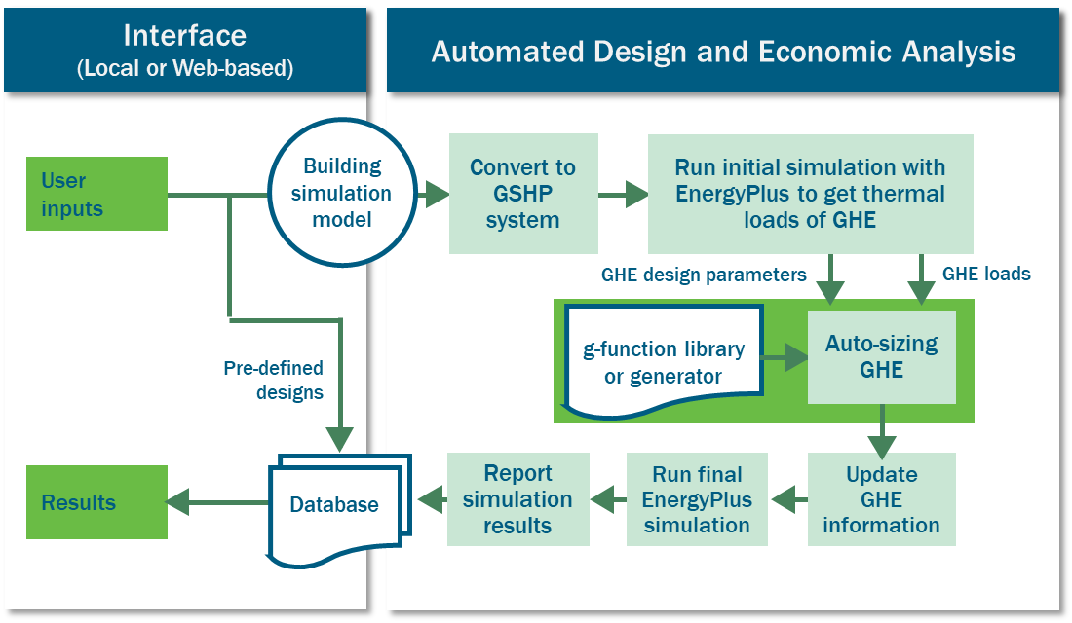

**Figure 1** Flowchart of the GSHP screening tool

The automated design and economic analysis start from a BES model, which can be an existing BES model (created with the OpenStudio program) or a simplified BES model created with ORNL’s AutoBEM program (New et al. 1998) for almost any existing building that can be specified through a satellite view of the US map. The design and economic analysis include the following subsequential steps:

1. Replace the existing HVAC system in the BES model with a GSHP system using an OpenStudio (OS) measure
2. Simulate the initial design of the GSHP system to get the thermal loads of the VBGHE. In this initial simulation, the borehole number is estimated based on the floor space of the building. Default values are used for borehole depth (200 ft or 61 m), response factors of VBGHE (i.e., the g-functions), and borehole design parameters. The program can calculate the undisturbed ground temperature based on a user-specified location of the building. Users can specify ground thermal properties or take default values
3. Size VBGHE with a new design tool to determine the borehole field arrangement and the depth of each borehole, as well as the associated g-functions
4. Update the input of the BES model with the above sizing results of VBGHE
5. Perform a simulation of the updated GSHP system to predict its performance and perform a simulation with the original HVAC system to establish a baseline for comparison
6. Report key performance metrics of the simulated GSHP system and pass them to the interface and a database.

The GSHP system was designed and simulated based on the following criteria. Default values of VBGHE design parameters are listed in Table 1.

* Existing HVAC systems in a building are replaced with a new distributed GSHP system, which provides independent climate control in each thermal zone of a building without using any supplemental heating or cooling system
* The rated heating and cooling coefficients of performance of the GSHP unit are 4.0 and 6.5, respectively. The EnergyPlus program auto-sizes and simulates water-to-air heat pumps of distributed GSHP systems. The entering water temperature of the heat pump is from the supply water temperature of GHE so the impact of GHE supply temperature on the heat pump efficiency is modeled in annual simulations.
* A VBGHE with boreholes laid out in a square of a near-square field with 6.1 m bore spacing is sized to maintain the leaving fluid temperature of the VBGHE between 1°C and 35°C year-round
* Outdoor air provided with a dedicated ventilation system in parallel with the distributed GSHP system
* Energy savings are not only from the higher operational efficiency of the GSHP system but also the avoided simultaneous heating and cooling, which is common in the conventional variable air volume (VAV) systems, as well as the improved fan control and fan efficiency

|  |  |  |  |
| --- | --- | --- | --- |
| Table 1. Default values of vertical borehole heat exchanger design parameters | | | |
| Parameter | Default value | Parameter | Default value |
| Borehole radius (m) | 0.0762 | Grout heat capacity (kJ/m3-K) | 3,901 |
| U-tube pipe thickness (m) | 0.002 | Ground conductivity (W/m-k) | 1.29* |
| U-tube pipe outer dia. (m) | 0.027 | Ground heat capacity (kJ/m3-K) | 2,347 |
| U-tube leg spacing (m) | 0.025 | Undisturbed ground temperature (°C) | Site-specific. Calculated with the method by Xing and Spitler (2015) |
| Pipe conductivity (W/m-K) | 0.39 | Bore spacing (m) | 6.1 |
| Pipe heat capacity (kJ/m3-K) | 1,542 | Maximum GHE supply temp. (°C) | 35 |
| Grout conductivity (W/m-k) | 1.29 | Minimum GHE supply temp. (°C) | 1 |

* The screening tool allows users to specify ground thermal conductivity value at a given site.

Simulations of DOE prototype models for 16 different types of commercial buildings (USDOE 2022) in 15 US climate zones (ASHRAE 2021) have been performed with an existing conventional HVAC system or a new GSHP system, respectively. The simulation results are stored and managed through a database. These pre-calculated results can provide a quick answer to the techno-economic viability of a GSHP application.

New design tool for VBGHE

The state-of-the-art design method for VBGHE, which is the most used GHE (especially for commercial buildings), is based on thermal response functions known as g-functions (Eskilson and Claesson 1988). A new g-function generator has been developed that overcomes the limitations of previous efforts. This generator can calculate g-functions on the fly during the iterative configuration selection and sizing process for VBGHE (Cook et al. 2021). In addition, an extended g-function library for more than 34,000 borehole field configurations has been generated and published to provide more options for designing VBGHEs (Spitler et al. 2021, Spitler et al. 2022a). The new g-function generator and the extended g-function library have been leveraged to develop a new design tool that can automatically select and size VBGHEs with flexible configurations. The new tool gives results that differ by less than 4% for the same burial depth and load representation as constrained to GLHEPro (2016), a widely accepted design tool for VBGHE. The new tool allows many alternative designs that are not possible with existing design tools, such as various spacing among boreholes, boreholes with inclined angles, or boreholes with nonuniform depths in a bore field. The new design tool can find the near-optimal borehole field arrangement within the user-specified available regular or irregular land area (Spitler et al. 2022b). Case studies have shown that the new tool can significantly reduce the required drilling (in some cases greater than 40%) while meeting the thermal loads by reducing interference between boreholes (Spitler et al. 2020, Spitler et al. 2022a, Spitler et al. 2022b). The reduced drilling requirement can help lower the cost and enable the wider adoption of GSHP systems.

Example of precalculated RESULTS

Simulations with various combinations of the following design parameters were conducted and the key simulation results were stored in a database. These precalculated results can provide a quick answer for the GSHP screening.

* Sixteen DOE’s commercial prototype buildings, which are designed based on the 2007 version of the American Society of Heating, Refrigerating and Air-Conditioning Engineers Standard 90.1 (ASHRAE 2011) to represent existing buildings that are near the time to retrofit their existing HVAC systems.
* Fifteen climate zones in the US
* Two HVAC systems: 1) Existing HVAC system in the prototype building and 2) Distributed GSHP system
* Four variations in Windows
  + Minimum code-compliant windows (used in the original prototype models)
  + High-performance windows
  + A 20% larger WWR than that used in the prototype models
  + High-performance windows and a 20% larger WWR
* Two levels of ground thermal conductivities (low, high)

Table 2 lists key screening results of the GSHP retrofit for 16 different types of commercial buildings in 15 climate zones in the US (indicated in the header using 1A-8A), which includes the percent annual energy cost savings, GHE length per system capacity, simple payback period, and annual ROI. As noted above, the current analysis does not include hybrid systems. The following observations can be made:

* Energy cost savings percentage from a GSHP system is generally higher in very hot or cold climates (note darker green columns for climate zones 1A, 2A, 2B, and 8A in the first table). However, the required length of GHE per ton of GSHP system capacity is also very high in these climates (note the red columns in the second table). This resulted in higher payback periods and lower or negative annual ROI for most building types in those climates (note red cells in the third and fourth tables).
* Small hotels, outpatient hospitals, and high-rise apartments are among a few building types that have a higher-energy cost savings percentage from a GSHP system installation in most climate zones (note rows with darker green cells in the first table). Even though these building types have the moderately high required length of GHE per ton of GSHP system capacity (note corresponding rows having lighter green cells in the second table) requiring higher capital cost, installing a GSHP system is generally cost-effective for these buildings in most moderately hot or cold climate zones with a lower payback period and a higher annual ROI (note green cells in the third and fourth tables).

|  |
| --- |
| Table 2. Examples of key screening results of GSHP applications[1] |









realtime simulation with automated model creation and simulation

For evaluating GSHP applications in other buildings that have not been pre-calculated, a fully automated process has been implemented to create a BEM and perform the screening analysis as depicted in Figure 2. The AutoBEM developed at DOE’s Oak Ridge National Laboratory is used to automatically create a BEM. The BEM is created based on a few characteristics of a building, including footprint, height, principal function, and age (New et al. 2018). AutoBEM has a database covering 98% of the 125,714,640 existing buildings detected in the US and it adopts other building properties, such as occupancy, equipment, and insulation, from the DOE prototype buildings to complete the BEM. With this fully automated process, a user can specify an existing building from a satellite view of a map and all the needed calculations will be performed automatically to determine the cost and benefits of retrofitting the existing conventional HVAC system with a new GSHP system.

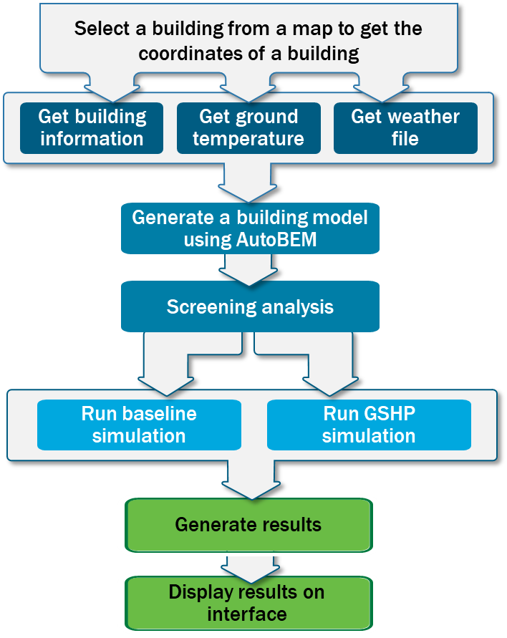

**Figure 2** Flow chart of an automated real-time simulation for a user-selected existing building

WEB INTERFACE

The web interface is built using the JHipster framework stack, which is composed of Java EE (a programming language) with MySQL (a relational database) and an Angular/HTML front end. The web application is composed of three web pages. The first page (Figure 3) collects user input for climate zone, building type, and vintage of the target building through dropdown menus. Also, a map feature allows a user to select the location of any existing building shown on the satellite view of the ma. The map feature will determine the climate zone of the location. Other fields on this page display more information about the target building, including the existing heating and cooling system (or the default HVAC system if it is new construction), the total floor area, and the number of floors.

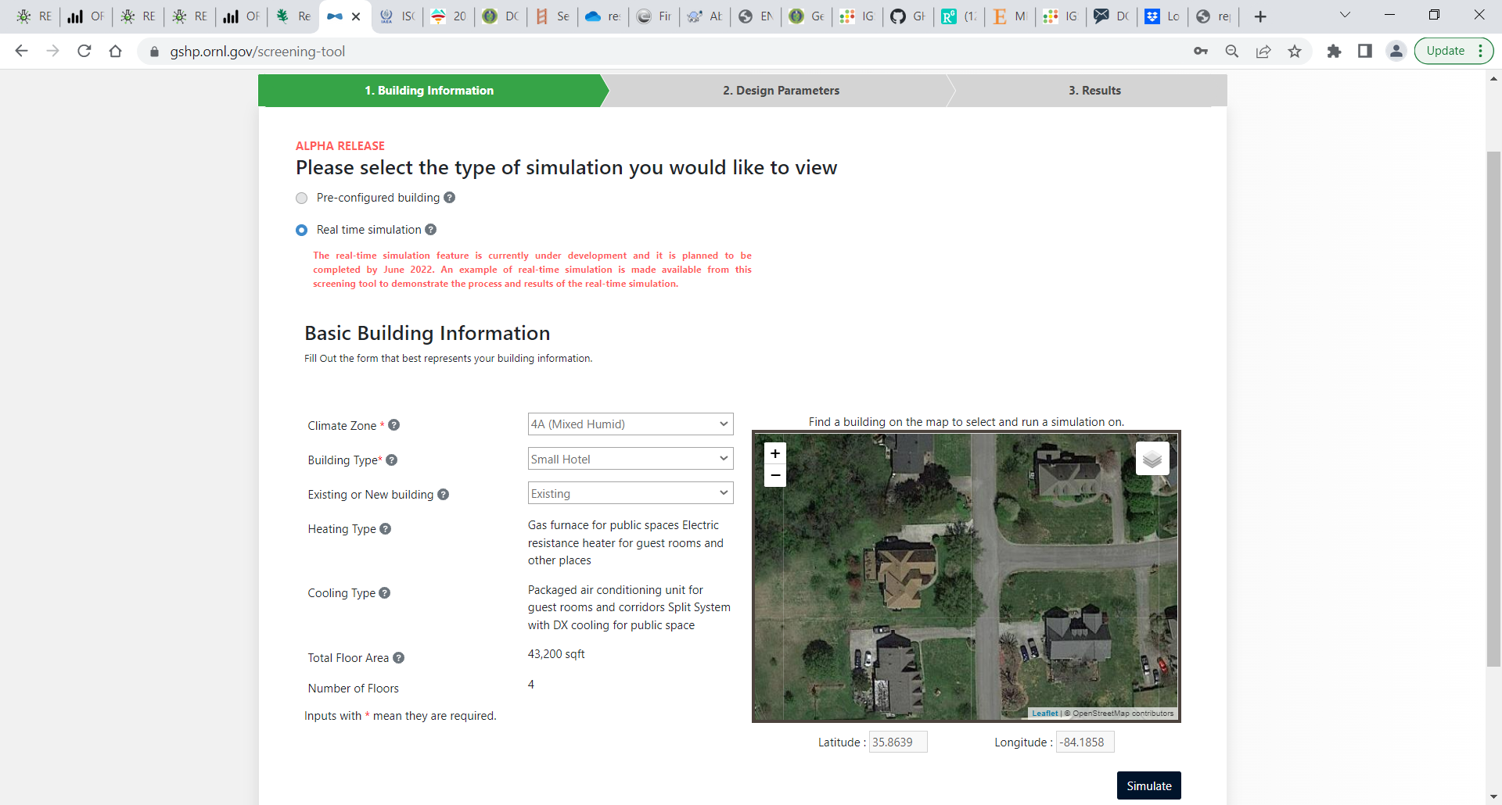

**Figure 3** The first page of the web-based GSHP screening tool for selecting a target building

The second page (Figure 4) allows users to select some design parameters of the building and the GHE. These parameters include the ventilation rate, window water ratio (WWR), window type, and ground thermal conductivity. Fields are set to default values on the page loading, but users can change them to select different values. Users can click on the “Simulate” button at the right-bottom of this webpage to display pre-calculated results or run automated design and analysis in real-time.



**Figure 4** The second page of the web-based GSHP screening tool for selecting design parameters

The results are displayed on the third page (Figure 5), including the total borehole length and the total capacity of the GSHP system, benefits, and the economics of the GSHP system compared with the conventional HVAC system commonly used for the simulated building. The displayed results include annual savings in electricity, natural gas, site energy, and source energy, as well as the reduction in annual carbon emissions, annual peak electricity demand, and annual water usage. In addition, the cost premium of the GSHP system[2], simple payback period, and the annual return on investment (ROI) is also displayed. These economic results can be updated in real-time based on user inputs of the prices of natural gas, electricity, water, and GHE.

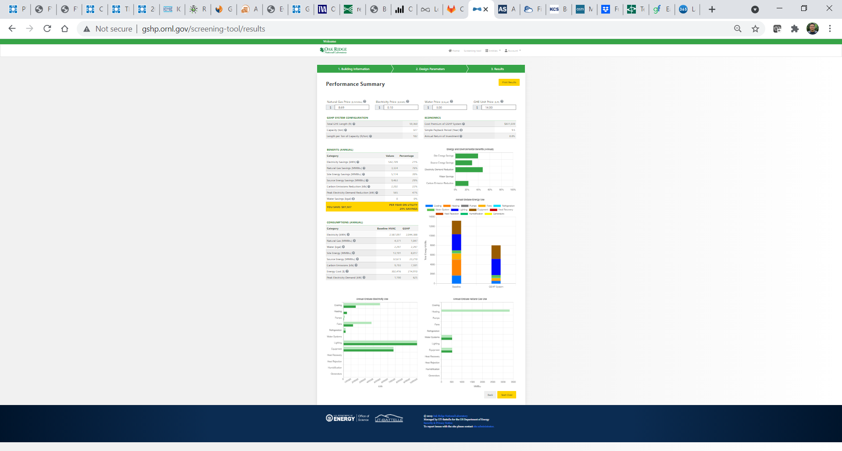

**Figure 5** The third page of the web-based GSHP screening tool for displaying results

CONCLUSIONS and Further Development

A web-based tool to quickly evaluate the techno-economic feasibility of GSHP applications has been developed to enable wider consideration and adoption of GHP technologies. A beta version of the tool (https://gshp.ornl.gov/) is now available online. This tool includes pre-calculated screening results with DOE prototype building models in 15 climate zones in the US. It also allows real-time simulation of almost any existing building in the US by integrating with ORNL’s AutoBEM to automatically create a building model based on simple inputs of footprint, height, function, and age of the building. The results of this tool include the design, benefits, and economics of the GSHP system compared with the conventional HVAC system commonly used for the simulated building. The economic results can be updated in real-time based on user inputs of the prices of natural gas, electricity, water, and GHE.

Further development is recommended to improve flexibility, convenience, and accuracy of the screening, including:

* Add a function to obtain utility rates from utility companies serving the region where the building is located
* Allow users to do what-if analyses to evaluate alternative designs of the building and the GSHP system, including hybrid systems in which part of the load is met through other systems (e.g., a GSHP combined with a cooling tower or boiler), user inputs for the desired supply temperature range of the GHE, and properly model the phase change of water in the ground surrounding the borehole when the GHE is allowed to run at below-freezing temperature.
* Compile and integrate a database of available ground thermal conductivities in the US
* Compile and integrate a database of the costs of conventional HVAC and GSHP systems in the US

ACKNOWLEDGMENTS

The development of this library was funded through the Department of Energy contract DE‐AC05‐00OR22725 with Oak Ridge National Laboratory. This project used resources of Oak Ridge National Laboratory’s Building Technologies Research and Integration Center. The US government retains and the publisher, by accepting the article for publication, acknowledges that the US government retains a nonexclusive, paid-up, irrevocable, worldwide license to publish or reproduce the published form of this manuscript or allow others to do so, for the US government purposes.

REFERENCES

ASHRAE. 2011. 90.1-2010 User’s Manual: ANSI/ASHRAE/IES Standard 90.1—Energy Standard for Buildings except Low-Rise Residential Buildings. American Society of Heating, Refrigeration, and Air-Conditioning Engineers (ASHRAE), Atlanta, Georgia.

ASHRAE. 2021. ANSI/ASHRAE Standard 169-2021—Climatic Data for Building Design Standards. ASHRAE, Atlanta, Georgia.

BLOCON. 2017. “Earth Energy Designer (EED) Version 4 Update Manual.” Retrieved February 13, 2019, from <https://buildingphysics.com/eed-2/>.

Cook, J. C. and J. D. Spitler 2021. Faster computation of g-functions used for modeling of ground heat exchangers with reduced memory consumption. Building Simulation 2021. Bruges, Belgium, IBPSA.

Eskilson, P. and Claesson, J. 1988. Simulation Model for Thermally Interacting Heat Extraction Boreholes. Numerical Heat Transfer 13(2): 149–165.

Gaia Geothermal, LLC. 2016. Ground Loop Design: Geothermal Design Studio 2016 Edition User's Manual.

GLHEPro 5.0 For Windows User's Guide. 2016. Oklahoma State University. Distributed by IGSHPA.

Liu, X., Hughes, P., McCabe, K., Spitler, J., and Southard, L. 2019. GeoVision Analysis Supporting Task Force Report: Thermal Applications—Geothermal Heat Pumps. ORNL/TM-2019/502, Oak Ridge National Laboratory, Oak Ridge, Tennessee.

Liu, X and G. Hellström. 2006. “Enhancements of an Integrated Simulation Tool for Ground-Source Heat Pump System Design and Energy Analysis.” Proceedings of the 10th International Conference on Thermal Energy Storage, Richard Stockton College of New Jersey, May 31–June 2, 2006.

National Renewable Energy Laboratory (NREL). 2020. “OpenStudio – Current Features.” http://nrel.github.io/OpenStudio-user-documentation/getting_started/features/.

Natural Resources Canada (NRC). 2005. Ground-Source Heat Pump Project Analysis. In *Natural Resources Canada’s Renewable and Electrical Energy Division*. https://publications.gc.ca/collections/Collection/M39-111-2005E.pdf

New, J. R., Adams, M., Im, P., Yang, H., Hambrick, J., Copeland, W., Bruce, L., and Ingraham, J. A. 2018. “Automatic Building Energy Model Creation (AutoBEM) for Urban-Scale Energy Modeling and Assessment of Value Propositions for Electric Utilities.” In Proceedings of the International Conference on Energy Engineering and Smart Grids (ESG), Fitzwilliam College, University of Cambridge, Cambridge, United Kingdom, June 25–26, 2018.

Spitler, J. D., J. C. Cook and X. Liu 2020. A Preliminary Investigation on the Cost Reduction Potential of Optimizing Bore Fields for Commercial Ground Source Heat Pump Systems. Proceedings, 45th Workshop on Geothermal Reservoir Engineering. Stanford, California, Stanford University.

Spitler, J. D., J. Cook, T. West and X. Liu 2021. G-Function Library for Modeling Vertical Bore Ground Heat Exchanger, Oak Ridge National Laboratory. <https://doi.org/10.15121/1811518>

Spitler, J.D. and J.C. Cook 2021. “Sizing Ground Heat Exchangers with Rectangular Constraints.” Oklahoma State University. Milestone Report Submitted to ORNL on 02/26/2021.

USDOE 2022. Prototype Building Models. <https://www.energycodes.gov/prototype-building-models> accessed May 7, 2022

Xing, L. 2014. Estimation of Undisturbed Ground Temperatures using Numerical and Analytical Modeling. PhD Thesis. Oklahoma State University.

1. Based on heating and cooling degree-days, ASHRAE (2021) defines climate zones 1 through 8 as very hot, hot, warm, mixed, cool, cold, very cold, and subarctic/arctic; and subclimate zones A, B, and C as moist, dry, and marine, respectively.
2. In the alpha release, the cost premium of the GSHP system is approximated as the cost of the GHE.